If you are not a member of Horsham and District Angling Association, but the member has supplied your email address as their designated email, please pass this newsletter onto the member
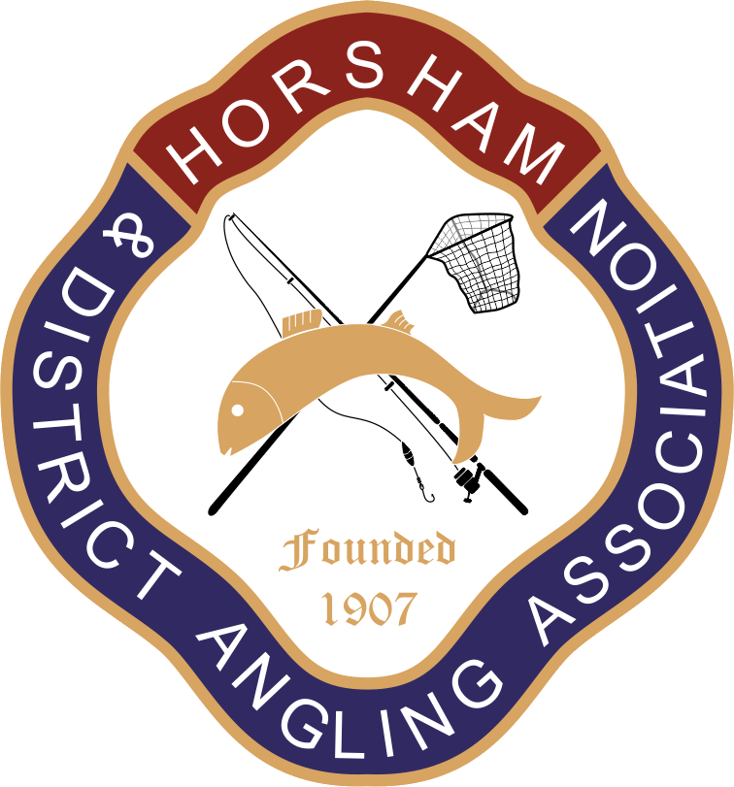

Horsham and District Angling Association 2023 Newsletter
Dear Members,
Welcome to the 2023 edition of the club’s annual newsletter. We hope that you have had an enjoyable season fishing the club’s waters.
As with the previous edition of this newsletter, we will continue with the paperless only format. This saves the club around £500 in expenses.
Please read the newsletter in its entirety. It contains important information that directly affects all members of our club.
Night Permits: If you wish to buy or renew a night permit, do not renew your regular club membership (if you wish to renew a current night permit, or are eligible to apply for the first time as stipulated in club rule number 20) without first contacting the membership secretary Ian Petch (tel: 0780 953 23 79; email membership@hdaa.co.uk) If you purchase a standard membership without a night permit you will not be able to purchase a night permit at a later point.

Membership Renewals: Membership renewals for 2023 – 2024 will be available from 1st May 2023. Members will have until 11th June 2022 to renew.

Newsletter Contents
- Club committee
- Annual General Meeting
- Club Waters
- Rule Changes
- Membership and Subscriptions
- Pike Teach-Ins
- Stocking
- Plans for 2023 – 2024.
1. Club Committee
There have been significant changes in club officials since last year. Barry Clark has taken over from Graham Sitton as Chairman. The Club Secretary’s role, previously held by Ian Petch has been split into 2 roles, General Secretary and Membership Secretary. Oliver Wright is the new General Secretary, whilst Ian Petch is acting as the Membership Secretary. Lee Waller and Tony Staples are joint Fishery Officers, replacing Les Eggleton in that role. The committee extends its sincere thanks to all former officials for their tireless work on the club’s behalf.
2. Annual General Meeting (AGM)
This year’s AGM will be held at The Roffey Social and Sports Club (Spooners Road, Roffey, RH12 4DY) on Wednesday 26th April. Please arrive at 7.30pm for an 8pm start. There will be food/snacks for those who attend and there is also a bar.
We strongly encourage members to attend the AGM. The club is run for your benefit and the AGM offers you the chance to meet committee members face-to-face and influence how the club is run. As usual, we will vote in the officers and committee and encourage those who wish to stand as officers, or to otherwise contribute to the running of the club, to do so.
For details of rule changes to be voted on at the AGM please see the “Rule Changes” section of the newsletter.
3. Club Waters
The committee really values the contributions of those who have joined work parties and otherwise assisted the fishery officers in carrying out work at the club’s waters over the past year. This help is vital in maintaining and improving our waters. We are always looking for additional help, so if you feel able to contribute, please contact our fishery officers Lee Waller (07598 510934) and Tony Staples (07833 603153).
The committee also wishes to acknowledge the work carried out by Kevin Rice and his team of bailiffs. They are out in all conditions keeping the club’s waters safe and secure, and ensuring that members follow the rules agreed by the club and its members. Please continue to treat them with the respect they deserve.
Roosthole: In a change from previous years, Roosthole will not be closed for a pre-announced period in May. This year, the water will be closed when carp start spawning and reopen when spawning ends. We hope this change will benefit the carp stocks and allow the club to keep the closure period to a minimum. Members will be informed by email and announcements on the club website. The announcements will unavoidably be made at short notice, so please make sure to check the club website and email before fishing Roosthole during the spring.
In addition to regular work maintaining the condition of the water, the club has carried out various improvements at Roosthole over the past year.
As the climate becomes hotter and dryer in Summer, the risk to fish stocks posed by rapid changes in water oxygen levels has increased. To address this risk, the club recently installed an aeration system. To avoid damaging this equipment, take care to not cast across it or fish right up to it.
Work improving swims and paths on the Horsham bank has also been carried out. Two disabled swims were installed in the Autumn, generously donated from the estate of the late Clive Bashford, for many years a great servant of the club. The path on the Horsham side has also been widened in places to improve access.
The fishery officers have carried a feeding program during the colder months and are monitoring the results. We expect this to result in improvements in the condition and weight of the fish.
Island Pond: Several swims along the dam have been improved/replaced. A grill has also been installed around the overflow to reduce the risk of it becoming clogged with debris.
Club member Pete Collins has, with the agreement of the fishery officers, carried out a considerable amount of work maintaining and improving swims and paths at Island Pond. The club also wishes to acknowledge the considerable expert help George Leigh has provided dealing with fallen trees and similar issues.
Foxhole Pond: A work party last Summer cleared vegetation, removed overhanging branches and cleared vegetation around swims.
Discussions were also held with the landowners regarding the instillation of an aeration system at Foxhole.
Club chairman Barry Clark has also been working with the Environment Agency to address issues with water quality during the summer months that have led to fish deaths.
Birchenbridge Pond: A work party last summer improved swims and clearing vegetation on the Horsham side of the pond.
BSA Lakes: The sharing of this venue with Billinghurst AS, has gone well and will continue for the foreseeable future.
We also carried out work clearing vegetation and overhanging branches in swims close to the dam at both lakes as well as on the paths around the lower lake.
Black Bottom/Sun Oak Farm Ponds: Improvements have been made to the path around Sun Oak, whilst a gate was installed at Blackbottom. Encroaching vegetation has been cleared around both ponds.
Lee Place (River Arun): The club have been working with Billingshurst AS to have improvements made to parking facilities at the venue.
4. Rule Change Proposals:
Changes to existing rules
Current Rule 54: None of the General Rules shall be altered or amended, or added to without the sanction of a majority at the Annual General Meeting, or a Special General Meeting convened for that purpose. Proposals for rule changes must be given in writing and be seconded in writing and submitted to the secretary by March 1st. In exceptional circumstances the Committee may submit propositions after March 1st. Any proposition due for consideration by the Annual General Meeting may be amended at the time of the Annual General Meeting, and without prior notice.
Proposed Rule 54: None of the General Rules shall be altered or amended, or added to without the sanction of a majority at the Annual General Meeting, or a Special General Meeting convened for that purpose. Proposals for rule changes must be given in writing and be seconded in writing and submitted to the secretary by March 1st. In exceptional circumstances the Committee may submit propositions after March 1st. Any proposition due for consideration by the Annual General Meeting may be amended at the time of the Annual General Meeting, and without prior notice. Those entitled to cast votes at the AGM are senior, OAP, disabled (over 18) and intermediate members. Juniors and minors, along with non-fishing members are not entitled to vote.
Note on the proposal to change rule 54: the club has always limited voting rights to senior, OAP, disabled and intermediate membership categories, though this is not formalized in the club’s rules and constitution. The proposal above intends to formalize that long informal understanding.
Current Rule 21: Members may use 3 rods at night from 11pm to 6am only subject to a further fee. (Remember 2 rod licences will be required.)
Proposed Rule 21: Members may use 3 rods from dusk to 6am only subject to a further fee. (Remember 3 rod licences will be required.)

Current Rule 24: Bait boats may only be used by Senior Members holding a valid night permit during the period between 30 minutes before sunset and 30 minutes after sunrise.
Proposed Rule 24: At Birchenbridge, Roosthole and Island Ponds only, bait boats may be used at any time, provided there are 2 unused swims either side of the angler intending to use the bait boat. This rule will be a trial for 1 year only.
Current Rule 47: NO DOGS, RADIOS, FIRES OR BBQs
Proposed Rule 47: NO RADIOS, FIRES, BBQs OR DOGS, EXCEPT THE HORSHAM BANK AT ROOSTHOLE WHERE DOGS ARE PERMITTED PROVIDING THEY ARE KEPT UNDER CONTROL AT ALL TIMES, DO NOT ENTER THE WATER AND ALL EXCREMENT IS REMOVED FROM THE SITE. This rule will be a trial for a maximum of 1 year only,

5. Membership and Subscriptions
Following discussion at the February committee meeting, subscription rates for 2023 - 2024 will be increased as detailed below.
Seniors - £105
OAP (over 65) - £78
Disabled - £78
Intermediate (16 - 17) - £45
Junior (10 - 15) - £15
Minor (under 10) - £5
Two-rod night permit - £30
Three-rod night permit - £35
Prices have increased for all membership categories except intermediate, junior, minor and non-fishing. Increases in subscription rates are proportionately larger for OAPs than for senior members. This is because relative numbers of OAP members compared to senior members has increased over recent years and, as this happens, the club’s income has become increasingly stretched. Rates for disabled members have been increased by a similar amount to match the OAP rate.
In setting rates, the committee must strike a balance between offering value-for-money, generating sufficient revenue and improving the experience offered to members. The decision to increase rates reflects substantial increases in the costs associated with running the club in the last year.
The committee regrets having to take this decision, but continues to believe that membership of the club offers excellent value for money.
Membership renewals for 2023 – 2024 will be available from 1st May 2023. Existing members have until 11th June 2023 to renew, at which point we will offer any unsold memberships to those on the waiting list. Members who do not renew in time and later wish to renew will have to join the waiting list, which is currently 2-years. Other clubs in the area have similar waiting lists.
If you are an existing member, follow the same process to renew as last year by logging into your profile on the club website and following the instructions to renew. Make sure all your details are all up to date, especially if you have moved and have changed address, as new memberships will be delivered to the address shown in your profile. If you have a new email address, then please let the membership secretary know. This complies with GDPR and keeps your personal details secure.
If you are an existing night permit holder and the offer of a night permit does not appear, DO NOT BUY A MEMBERSHIP WITHOUT CONTACTING THE MEMBERSHIP SECRETARY. If you have completed the two-year probation period and wish to obtain a night permit for the first time, then YOU WILL ALSO NEED TO CONTACT THE MEMBERSHIP SECRETARY to be sent the night permit offer.
6. Pike Teach-Ins
As per rule 39, those wishing to fish for pike on our waters are required to attend a pike teach-in. Ian Petch will run one or two of these at Island Pond as in previous years, and all members will be informed of the dates and invited to attend by email, nearer the time. An attendance card is issued to those who come along, and bailiffs subsequently check anyone pike fishing on our waters to make sure that they have done so and are in possession of this card.
7. Stocking
A specimen carp, kindly donated to the club by Graham Sitton, was stocked at Roosthole in October 2023.
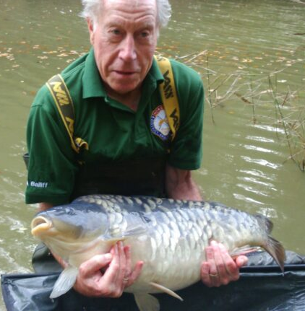
Beyond that, the club did not introduce further stocks throughout last year, though funds have been set aside to pay for stocks in the coming season. In particular, we plan to introduce some large tench to our waters, as well as specimen roach and bream.
8. Plans for 2023 - 2024
Maintaining and improving club waters is an ongoing process. With relatively limited resources at our disposal, the club cannot undertake all the work it would like to and so has to prioritize the work it carries out.
In addition to regular maintenance work to keep venues fishable, the committee has decided to focus on the projects mentioned below over the coming season.
At Roosthole, the fence at the top end of the water is in an increasingly dilapidated state. We intend to replace this fence to provide long term security to the venue. Meanwhile at Blackbottom pond, a project is underway with Natural England to improve the condition of the bank next to the public footpath. This will stop the ongoing erosion to the bank and allow the habitat to recover. As part of this project, access to water from the footpath will be blocked off.
At Foxhole and Island Ponds, a number of swims have been earmarked for replacement or renovation. We will also be installing an aeration system at Foxhole and plan to repair the bridge over the outflow. We have also reached an agreement with Billingshurst AS, with whom we share BSA lakes to jointly renovate and repair a number of swims each year (2 for each club), starting with those nearest the car park. Given the large numbers of swims at the venue and the poor condition of many of them, we expect this will be an ongoing project.
Finally on the Horsham side of Birchenbridge, work improving the condition of the footpath along the bank is currently being planned. By the end of next season, the club should have a bridge along the section of the path that is usually very muddy due to the springs/seeps that discharge there.
“Get fishing” initiative: The club has recently received a grant from the Angling Trust “Get Fishing Fund” to put on a series of fishing events over the Summer. These will be introductory events for children, especially those with no experience of fishing. They will be held at Foxhole Pond.
In connection with this, the club would also like to appoint an individual to assist in developing the junior section of the club. This role would involve reinvigorating the junior section of the club by organizing events such as matches and teach-ins, aimed at younger members, as well as driving up numbers of junior members of the club.
The role should appeal to anyone enthusiastic about sharing their angling knowledge and skills with youngsters and anyone who cares about the long-term future of angling and our club. The holder would be expected to join the committee and would not be a club officer initially, though if the club can successfully fill the role, it intends to add it to the list of club officials.
If you are interested in the role, the General Secretary Oliver Wright (07453 028 355) would be delighted to hear from you.
Matches: Like many other clubs in the area, the numbers of anglers participating in matches has steadily decreased over the years. Given this, the club has, regrettably, decided to discontinue the previous match schedule.
In their place, the club proposes to hold 6 evening matches in the 2023-24 season, with 2 each at Island Pond, Foxhole and Birchenbridge. The club will also hold a second edition of the “Bailiffs Cup” match, again at Roosthole, on the 8th July. Further details will be published in due course. The club hope that many of its members, both those who regularly fish matches and others who may wish to give it a try, will support these events. Please contact Ray Smallwood (07752 331594) if interested in taking part in the evening matches.
New Facebook Page: The club will launch a new Horsham and District Angling Association Facebook page run by the committee at the start of June. This will act as supplement to the club website, which will remain the source of official club news and announcements. We will contact members to let them know how to join closer to the time. We hope you enjoy it and find it an informative source of information about the club.
This concludes the annual newsletter. We hope very much to see you at the upcoming AGM.
Tight Lines
H&DAA

