If you are not a member of Horsham and District Angling Association, but the member has supplied your email address as their designated email, please pass this newsletter onto the member
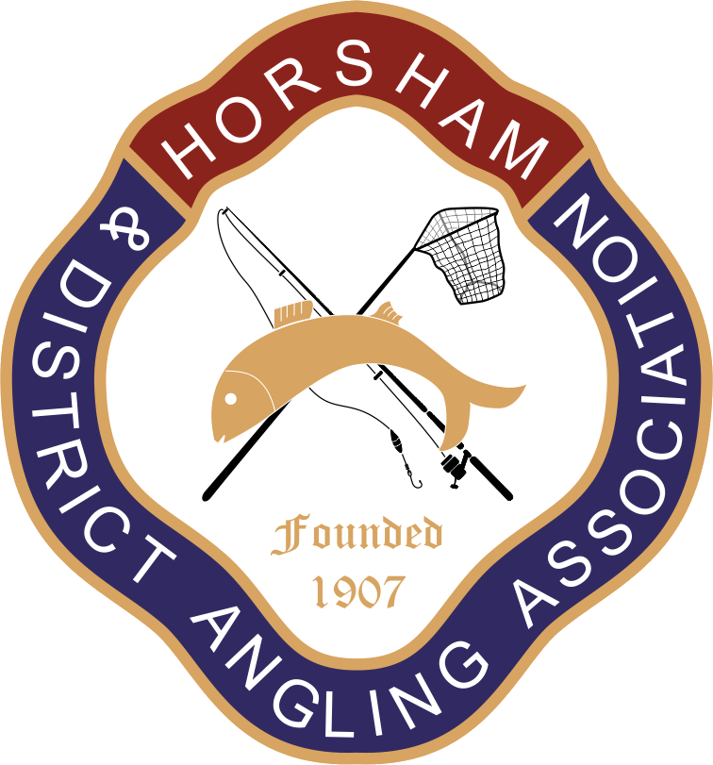

Horsham and District Angling Association (H&DAA) 2024 Newsletter
Dear Members,
Welcome to the 2024 edition of the club’s annual newsletter. We hope that you have enjoyed fishing the club waters during the past year and will continue to do so during the coming season.
Last season was a successful one for the club. This is down to the hard work of volunteers who give up their free time to help out. Highlights included a series of matches Mark Hayley organized during the Autumn, the development and start of work on a long-term plan to improve Roosthole, led by out fishery officers and a series of fishing events for children ran over the summer.
As always, a lot of work goes on behind the scenes to ensure that H&DAA continues to offer high quality fishing in beautiful and peaceful surroundings. This newsletter can only give a flavour of all the work has been done in the last twelve months.
Please take the time to read through this newsletter. It contains important information that affects all members of our club.
Night Permits:
If you wish to renew a night permit or apply for one for the first time, do not renew your regular club membership without first contacting the membership secretary Mark Haley (tel: 07900 887 501; e-mail membership@hdaa.co.uk)
If you purchase a standard membership without a night permit you will not be able to purchase a night permit at a later point.

Membership Renewals: Membership renewals for the coming season will be available from 1 May 2024. Members will have until 16 June 2024 to renew. After that point, the club will offer remaining spaces to those on the waiting list, starting with those who have been on the list for longest. Any existing members who wish to renew, but fail to do so before June 16, will be added to the waiting list.

Newsletter Contents
- Club committee
- Annual general meeting
- Club waters
- Membership and subscriptions
- Rule changes
- Pike teach-Ins
- Stocking
- Plans for 2024 – 2025
Ian Petch: Ian served as the club secretary (and more recently membership secretary) for more than 20 years. He took up the position only reluctantly, at a time the club was struggling to find anyone to take on the role and was at first unsure he had the necessary skills.

But as long-standing members of the club will know, he managed the position superbly, providing the stability, expert knowledge and leadership that has allowed the club to thrive.

It’s hard to pick out significant work Ian has done for our club, as there have been so much of it, but highlights include;
- building up the club’s portfolio of water, including such [popular venues as Island Pond and Foxhole
- working with the police and EA to address fish thefts from Island Pond – which led to the perpetrators paying for new stock
- setting up the clubs first website
- micro-chipping almost all our large carp, virtually eradicating fish theft
- introducing clubmate, revolutionizing the way the club is administered.

In addition to working as club secretary, Ian has been heavily involved around the club’s venues; building paths and swims, raising water levels at Roosthole and repairing leaking dams. Much of this work was completed with the two other long-standing servants of the club, Les Eggleton and Tim Woodhatch, who put the maintenance of venues on a far more professional footing than previously.

Karen Petch also gave invaluable technical support to Ian in his role as club secretary.

Ian has also introduced many members to pike fishing through the teach-ins he has run.

The club has been and will continue to be truly fortunate to have such a dedicated and conscientious individual as Ian involved. We all owe him a real debt of gratitude.

1. Club Committee
There have been several changes to the committee since the last newsletter.
Ian Petch is stepping down as an officer after many years sterling service, most recently as the membership secretary (see box). Wayne Ellis and Bob Wood have also stepped down from the committee in the past year. I’m sure all members of the club will want to join the committee in expressing their heartfelt appreciation of Ian, Wayne and Bob.
Three new committee members will be joining - subject to ratification at the AGM. They are Pete Collins, Tom Sayers and Mark Haley (who will be standing as membership secretary). Many members will know them already. Tom and Pete are both bailiffs and Mark ran a highly successful series of matches last Autumn.
We will also - again subject to ratification at the AGM - add a new official role to the club committee. This will be the Welfare Officer. Details of the role and why it is needed have already been communicated with members via e-mail. Existing committee member Chris Jenkinson will be standing for this role.
2. Annual General Meeting (AGM)
This year’s AGM will be held at The Roffey Social and Sports Club (Spooners Road, Roffey, RH12 4DY) on Wednesday 17th April. Please arrive at 7.30pm for an 8pm start. There will be food/snacks for those who attend. There is also a bar.
We encourage all members to attend the AGM. The club is run for the benefit of its members and the committee needs their input to function properly. The AGM offers you the chance to meet committee members face-to-face, have your say, and to influence how the club is run.
As usual, we will vote in the officers and committee during the AGM. Anyone who wishes to stand as a club officer, is encouraged to do so at the AGM.
We will also vote on changes to the club rules. There are several significant changes proposed this year. For further details, see the newsletter section “Rule Changes”.

3. Club Waters
Our club depends on volunteers to carry out work maintaining and improving our waters. This saves the club thousands of pounds each year and is critical in keeping the costs of membership down.
Things don’t always go to plan… A few weeks after the roadside fence was replaced at Roosthole, a car crashed into it.
So a big thank you to everyone who has contributed to work on our waters in the last year. Our two fishery officers (Lee Waller and Tony Staples) are incredibly dedicated and hard-working, but the support and help they get from others is vital in ensuing they can carry out all the work that needs to be done.
Lee (07865 439 818) and Tony (07833 603 153) always need of extra help, particularly from anyone with specialist skills. We also publicise work parties on the club’s Facebook page and website. If you are able make a contribution, however large or small, it will make a difference.
The club also depends on the work carried out by Kevin Rice and his team of bailiffs who ensure that the club’s waters and assets remain safe. Please continue to treat them with the respect they deserve.
Roosthole: As anyone who has been down there recently will have noticed, significant work has been carried out at Roosthole in the last year. Much of it is connected to the plan to develop the venue and improve the aquatic habitat. To this end, the lake has been treated with bio-aqua to reduce the build-up of organic silt and a significant program of vegetation clearance on the Horsham bank has been initiated. We’ve also installed numerous coir rolls containing water plants.
Barry and Dawn Clark with Kevin Rice installing disabled swims at Roosthole. These were donated to the club from the estate of our late Chairman, Clive Bashford 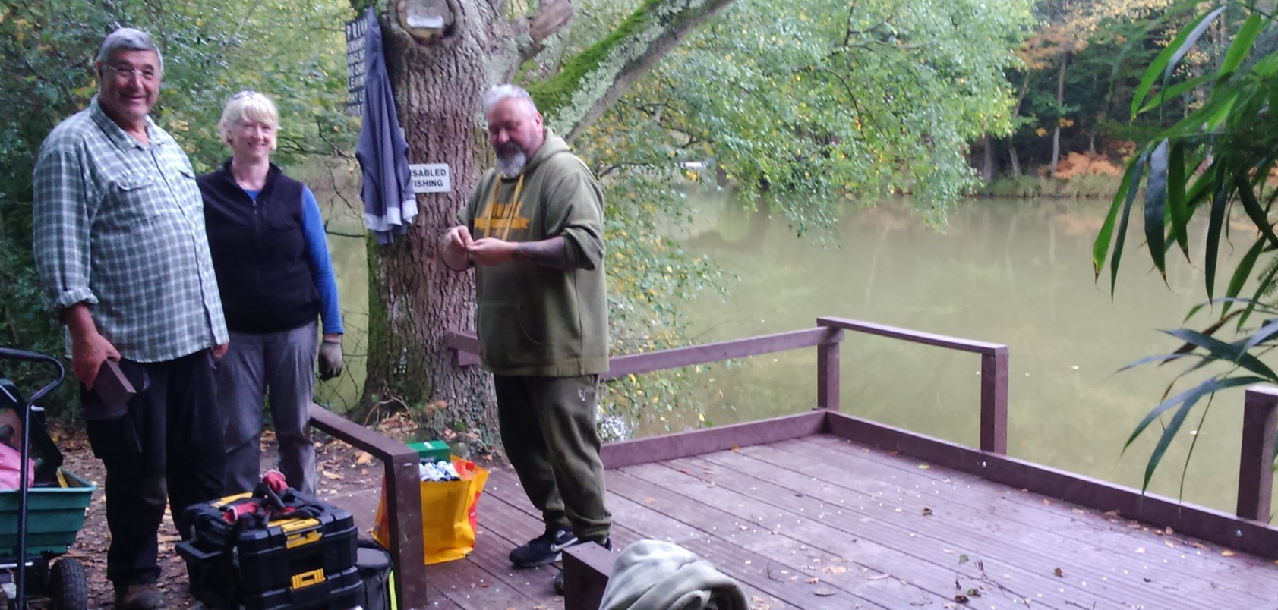
We expect to see the first benefits of this work immediately, but the true value will be shown in the medium-term as increased light and wind reach the water. Along with the addition of aquatic plants this will boost water quality and provide a better environment for invertebrates. This, in turn, will provide more natural food for the fish.
The fishery officers have also worked to improve the security of the venue and the amenities offered to our members, including renewing the fence along Hammerpond road, whilst swims have been renovated and the bankside path has been improved.
Following a successful trial last year, Roosthole will be closed during the period when the carp spawn.
Members will be informed by e-mail and announcements on the club website and Facebook. Announcements will unavoidably be made at short notice, so please make sure to check before fishing Roosthole during the spring.

Island Pond/Foxhole: Work parties have visited both venues several times improving and replacing swims earmarked for renovation and clearing vegetation. In the longer term, the club has secured the agreement of the landowner to conduct a major cutback of the rhododendrons at Foxhole.
Pete Collins hard at work, as he often is, improving swims at Island Pond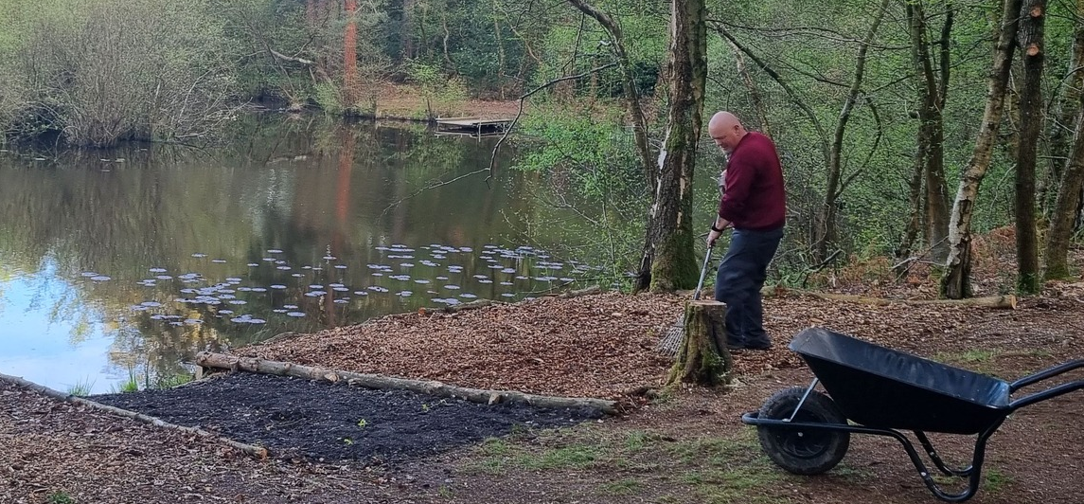
An aeration system was also installed on the island at Foxhole. This will help address the water quality issues experienced at the venue in recent summers, when hot weather caused algal blooms and fish deaths.
Birchenbridge Pond: A work party last summer improved swims and cleared vegetation on the Horsham side of the pond.
Bury St Austin (BSA) Lakes: We share BSA with Billingshurst AS and work parties from both clubs visited last summer, clearing vegetation, and tidying up, especially around the car park. There is much work to do at BSA, but most of the club’s resources have been directed at other venues in the last year.
Members should take extra care fishing BSA lakes as the water becomes very deep, very quickly.
Some swims are also rather cramped and precarious, particularly on the lower lake. So please take special care when at the venue to ensure that you are fishing safely.

Looking ahead, H&DAA will continue to share the venue with Billingshurst AS. We have held discussions with Billinghurst regarding developing the venue and secured an extended lease of the lakes. This will allow the club to implement longer-term plans.
Black Bottom/Sun Oak Farm Ponds: Both Black Bottom and Sun Oak ponds (and Island Pond) are part of a Site of Special Scientific Interest (SSSI), which places restrictions on the work that we can do, and the quantity and species of fish we can stock.
A section of the new fence beside the path at Black Bottom pond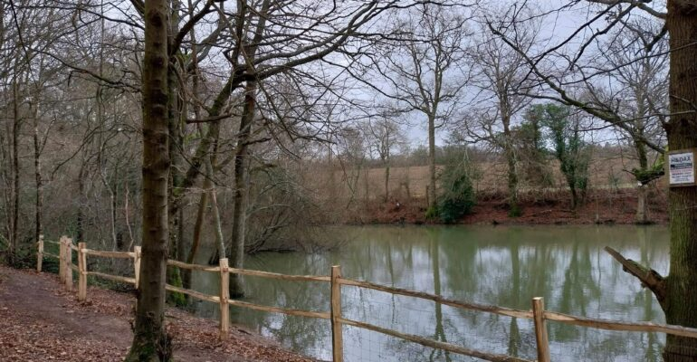
Having said that, the club secured a grant from Natural England to make improvements to the habitat at both venues. As well as work to clear non-native plants, Lee, Steve Jones and Liam Hawkins installed a fence at Black Bottom between the public footpath and the bank. This will prevent walkers (and their dogs) from accessing the lake and allow the bank, which has become heavily eroded and degraded, to return to a more natural state.
4. Membership and Subscriptions
Subscription rates for 2024 - 2025 will remain the same as last season, as detailed on
Renewals will be available from 1st May 2024. Existing members have until 16th June 2024 to renew, at which point we will offer any unsold memberships to those on the waiting list. Members who do not renew before this time and later wish to renew will have to join the waiting list, which is currently lengthy!
If you are an existing member, follow the same process to renew as last year by logging into your profile on the club website and following the instructions to renew. Ensure your details are all up to date, especially if you have moved and have changed address or e-mail. New memberships will be delivered to the address shown in your clubmate profile.
If you are an existing night permit holder and the offer of a night permit does not appear, DO NOT BUY A MEMBERSHIP WITHOUT CONTACTING THE MEMBERSHIP SECRETARY. If you wish to obtain a night permit for the first time, then YOU WILL ALSO NEED TO CONTACT THE MEMBERSHIP SECRETARY to be sent the night permit offer.
5. Rule Changes
A substantial number of changes and additions to club rules have been proposed this year by committee members. These are detailed in an annex at the end of the newsletter. Additional rules changes may also be proposed by members at the AGM (not included in the annex for obvious reasons).
Please read these rule changes as they will be debated and voted on at the AGM. If you have strong feelings about any of them, or would like to propose any other rules, we look forwards to seeing you at the AGM.

6. Pike Teach-Ins
Those wishing to fish for pike on our waters are required to attend a pike teach-in. Ian Petch will run one or two of these at Island Pond as in previous years. Members will be informed of the dates and invited to attend nearer the time. An attendance card is issued to those who come along, and bailiffs subsequently check anyone pike fishing on our waters to make sure that they have done so and are in possession of this card.
In addition to the pike teach-ins, Lee Waller also intends to organize a predator day, where members can learn the specialized techniques used to catch and to safely handle predatory species such as perch, pike and eels.
7. Stocking
Stocking last season was limited to a single large carp (named “bubbles”) in Foxhole (generously donated by committee members Pete Collins and Tony Staples and Lee Waller).
“Bubbles” about to meet her new home 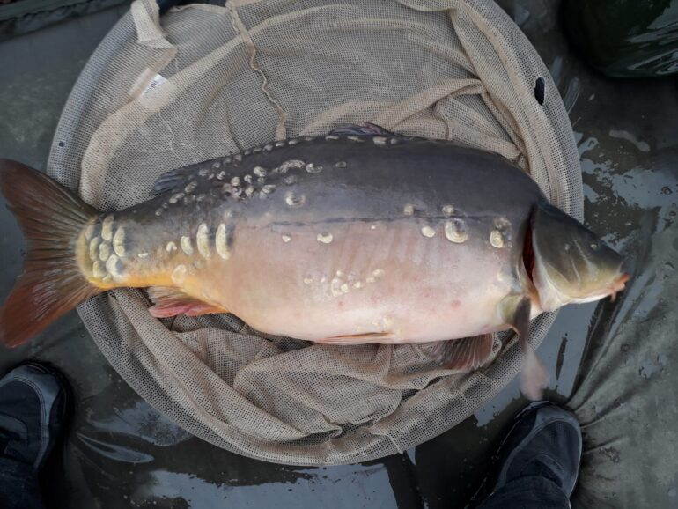
Plans to introduce other stock – notably large tench, roach and bream – mentioned in the previous newsletter have not yet been realized due to difficulties in sourcing suitable stock. The club has set aside a fund to pay for this and expects to carry out the stocking in due course. At present, reports indicate our waters hold a large stock of fish.
8. Plans for 2024 - 2025
Maintaining and improving club waters is, as ever, an ongoing and time-consuming process. With the relatively limited resources at our disposal (both financial and in terms of manpower), the club has to prioritize the work it carries out.
A busy scene from Roosthole working to remove a tree that had fallen into the lake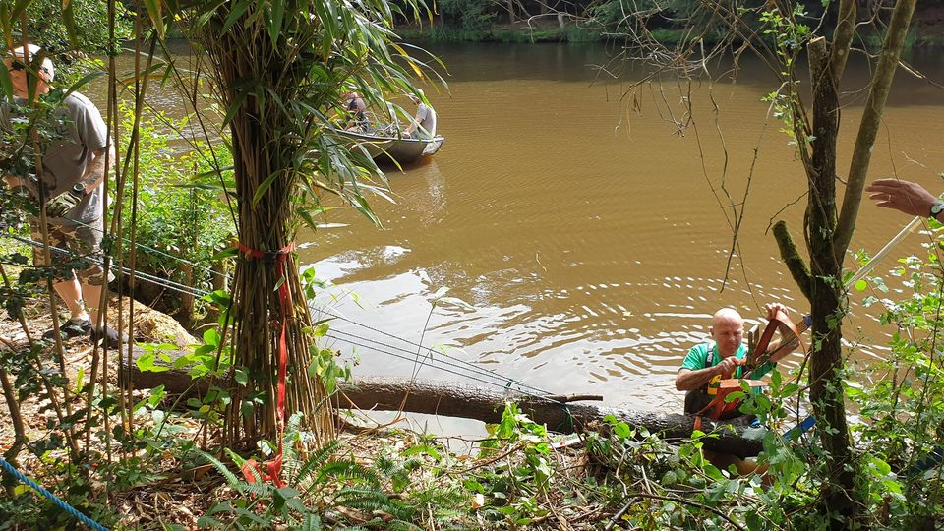
In addition to regular maintenance work to keep venues fishable, the committee will focus on its efforts on the ongoing project to improve Roosthole. Further applications of bio-aqua will be required to deal with the organic sediment and fish stocks will be assessed by electro-fishing, enabling us to make future stocking decisions on a more informed basis. There remains extensive work to be done reducing cover along the Horsham bank.
At Foxhole we intend to continue similar work clearing bankside rhododendrons to make the venue more open and improve water quality. Plans are also being developed to carry out substantial maintenance and improvement work at Birchenbridge.
BSA is a venue with huge potential for improvement, but making these improvements will require considerable work. Billingshurst angling society with whom we share the lakes, have agreed to contribute to development work. Over the next year we plan to make a start by carrying out a survey of the trees and removing those that are in danger of falling over. We also hope to replace/renovate a number of swims, starting with those around the car park. Over time we plan to work out way gradually around the lakes but, as mentioned in last year’s newsletter the large numbers of swims and the poor condition of many of them means this work will be ongoing for a number of years.
“Get fishing” initiative: The club plans to organize further fishing events for children over the coming Summer, building on the success of a series of similar events held last year at Foxhole.
Club treasurer Ray Smallwood with a first-time angler at one of the junior fishing events last summer
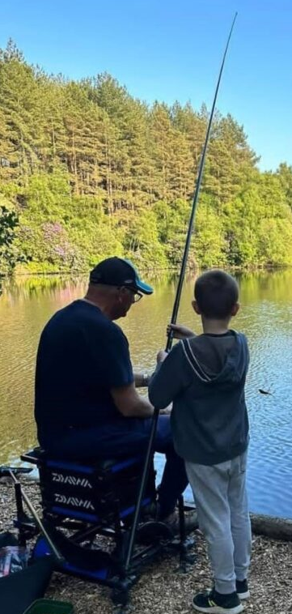
The club is still looking to appoint someone to develop the junior section of the club, as this is important for the club’s long-term sustainability.
If you are interested, please get in touch with Oliver Wright (07453 028 355).
Matches: Despite announcing the discontinuation of the long-standing match schedule last year, the match schedule in the 2023/2024 season was much busier than anticipated.
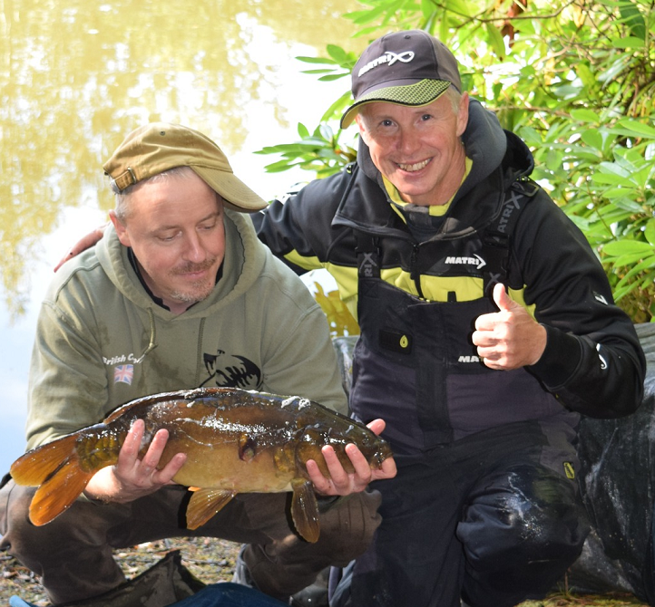
Fishery officer Lee Waller with Mark Hayley at the first of the Autumn matches Mark organized last year. Lee won the match!
In addition to the evening matches Ray Smallwood ran over the Summer, Mark Hayley organized and ran a well-attended series of matches over the Autumn, and the Bailiff’s Shield match was run for a second time.
This season, Mark will run a similar series over the Spring and Summer this year, whilst Ray also plans to organize another set of evening matches. The third edition of the Bailiff Cup match will also be held in July at Roosthole.
Mark is particularly keen to encourage people who might not have fished matches before to the join the matches he is organizing. The Autumn matches fostered a friendly and accommodating atmosphere and were much enjoyed by novice and experience match fishers alike. The matches he is organizing over the Spring and Summer will be run on a similar basis.
Watch for announcements about all the matches the club will hold in the coming season on the club website and on Facebook. Details of match dates where they have already been pencilled in can be found on the match fixtures page of the club website.
***
This concludes the annual newsletter. We hope very much to see you at the upcoming AGM.
Tight Lines
H&DAA
*** ***

Annex
Rule changes proposed by committee for 2024 AGM
Existing Rule 4: The business of the Association shall be conducted by a Committee of six, plus the Chairman, Secretary, Treasurer, Match Secretary, Fishery Officer and Head Bailiff. A quorum shall be formed of 6 of these persons, all of whom shall be elected at the Annual General Meeting. The AGM shall also elect the President, Vice-Presidents and Auditor. In the event of a vacancy arising among the officers from any cause whatsoever, the Committee shall have the power to fill up any such vacancy until the next AGM. The date of the AGM will be given on the Membership card.

Proposed Change: The business of the Association shall be conducted by a Committee of up to six, plus the Chairman, General Secretary, Membership Secretary, Treasurer, Match Secretary, Fishery Officer, Head Bailiff and Welfare Officer. A quorum shall be formed of 6 of these persons, all of whom shall be elected at the Annual General Meeting. The AGM shall also elect the President, Vice-Presidents and Auditor. In the event of a vacancy arising among the officers from any cause whatsoever, the Committee shall have the power to fill up any such vacancy until the next AGM. The date of the AGM will be communicated to members by email and advertised on the club website at least one month in advance of the event.

Explanatory note: the changes formally split the secretary role into two distinct roles, general secretary and membership secretary. A new officer role “Welfare Officer” is also proposed.
As the date of AGM is no longer on the membership card, the proposed change also ensures that the date of the AGM is publicized well in advance of the AGM.

*
Existing Rule 14: Membership cards must carry the Member’s photograph with the Member’s signature being carried across the photograph and Members must not enter Association waters without a properly completed Membership card containing their photograph.

Proposed Change: ‘Clubmate membership cards must be carried at all times by all members when on our waters.’
*
Existing Rule 17: New Members joining the Association after 1st December shall pay half price.
Propose to remove this rule completely.
*
Existing Rule 20: A night fishing permit is available to Senior, OAP and Intermediate Members only (not Minors or Juniors) who have been Association Members for at least two full seasons, subject to an additional fee which shall be notified on the renewal advice. From 1st December qualifying Members may purchase a half price night permit. Existing night permit holders may also upgrade their night permits from 2 to 3 rods at half price.

Proposed change: A night fishing permit is available to all categories of fishing member over 18 years of age who have been Association Members for one full season, subject to an additional fee which shall be notified on the renewal advice.

*
Existing Rule 23 a and e: The night permit is subject to the following conditions:
- Maximum number of permits to be 45, issued on a first come first served basis, but with preference given to existing night permit holders.
Proposed change: a) Maximum number of permits to be 55, issued on a first come first served basis, but with preference given to existing night permit holders.

e) Carp sacks must only be used for single specimen fish caught during the hours of darkness. Any member breaking this rule will have the night permit withdrawn immediately and may also have his general Membership withdrawn at the discretion of the Committee.

Proposed Change: e) Carp may not be retained other than for the purposes of getting ready to weigh or photograph, which must be done immediately. Any member breaking this rule will have their membership withdrawn at the discretion of the committee.

*
Existing Rule 24: At Birchenbridge, Roosthole and Island Pond only, bait boats may be used at any time, provided there are 2 unused swims either side of the angler intending to use the bait boat. At Foxhole Pond bait boats may only be used by Senior Members holding a valid night permit during the period between 30 minutes before sunset and 30 minutes after sunrise.

Proposal: retain this rule permanently – it was voted in at 2023 AGM on a 1-year trial basis.

*
Existing Rule 28: Senior, OAP, and Intermediate Members who have been Association Members for at least two full seasons not in possession of a full night permit may purchase a one-night permit for an additional fee. One-night only tickets will not be available for Saturday nights. See membership card for further details.

Proposed change: All categories of fishing member over 18 years of age who have been Association Members for at least one full season not in possession of a full night permit may purchase a one-night permit from the Membership Secretary for an additional fee. One-night only tickets will not be available for Saturday nights. See club rules for further details.

*
Rule 35 Carp sacks may only be used for single specimen fish caught during the hours of darkness.

Propose to remove this rule completely.

*
Golden Rule and Rule 43

Golden rule: MINIMUM 36” OR 30” SPOON LANDING NETS MUST BE USED ON ALL WATERS (EXCEPT BSA & FOXHOLE) & 42” WHEN FISHING FOR PIKE SEE RULE 43 FOR FULL DETAILS

Existing Rule 43) When fishing for pike, a minimum 42-inch landing net or a specifically designed folding rubberised pike net minimum 70cm x 85cm must be used. At all other times the angler must be in possession of a 36-inch triangular net or a 30-inch spoon net which must be set up and ready for use on all waters other than Foxhole and BSA lakes and used for landing specimen carp. Smaller landing nets can be used for silver fish, but the angler must be in possession of the larger net.

Proposed changes to remove wording referring to BSA and Foxhole.

Note: This proposal would set a minimum landing net size for all H&DAA venues (except the River Arun at Lee Place, which is governed Billinghurst AA rules).

*
Golden Rule and Rule 47:

Golden rule: NO RADIOS, FIRES, BBQs OR DOGS, EXCEPT THE HORSHAM BANK AT ROOSTHOLE WHERE DOGS ARE PERMITTED PROVIDING THEY ARE KEPT UNDER CONTROL AT ALL TIMES, DO NOT ENTER THE WATER AND ALL EXCREMENT IS REMOVED FROM THE SITE.

Existing Rule 47) No member shall leave any gate unfastened or do or permit any damage to fences, mowing grass, or crops near or adjoining the river or pond, or shall be accompanied by a dog (with the exception of bona fide Association Bailiffs) except on the Horsham Bank at Roosthole where dogs are permitted providing they are kept under control at all times, do not enter the water and all excrement is removed from the site.

Proposal: retain these rules permanently – they were voted in at 2023 AGM on a 1-year trial basis. The relevant section of the rule relates to dog.

*
Rule 40: Pike Season: Pike fishing is only allowed on Association waters between: 1st November and 15th March.

Proposed change: “Pike fishing is only allowed on Association waters between 1st November and 15th March. The start date may be moved forwards or delayed by the committee, depending on water temperatures. Any changes to the start date of 1st November will be communicated to members by email and advertised on the club website.”

*
New rule proposals:
“No fixed lead, beachcaster or twig rigs are allowed: in the event of a breakage, the lead/weight must be able to come free.”

“No fish being photographed should be held over knee height and always over an unhooking mat or cradle.”

“3 rods may be used at Birchenbridge during the day by members holding a 3-rod night permit and EA 3-rod licenses. Any rods that infringe on another angler’s swim, even if they arrive later, must be reeled in and relocated.”

