

# H&DAA Clubmate Renewal process.

Hello everyone, as promised, here is a quick guide to the membership renewal process.

First log into your clubmate account with your email address via a web page on a PC (there is a link on the club's web page under “buy a membership”) or via the app on your phone or tablet.

It should look like this...

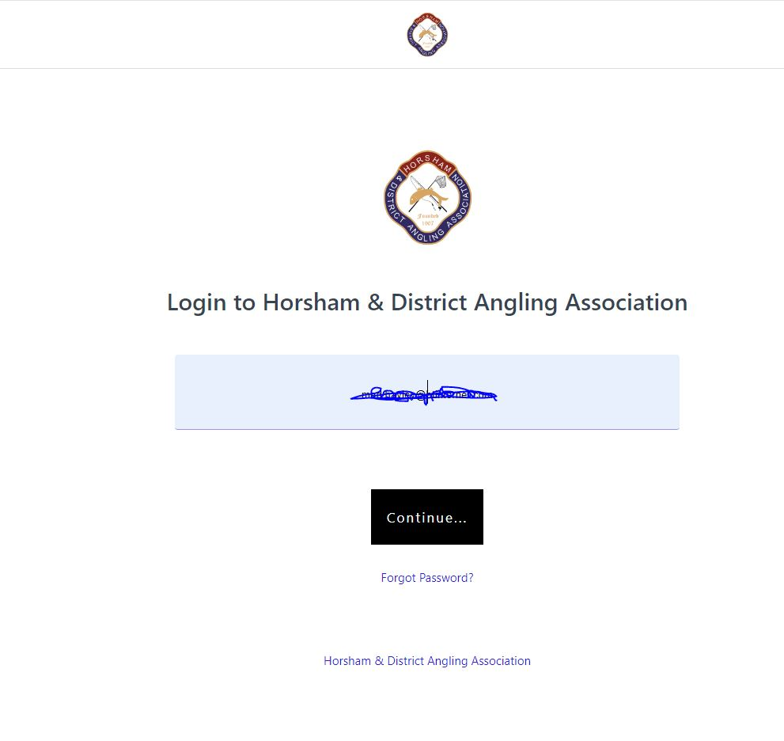

Then enter your password (if you have forgotten it you can request a new one on the page)

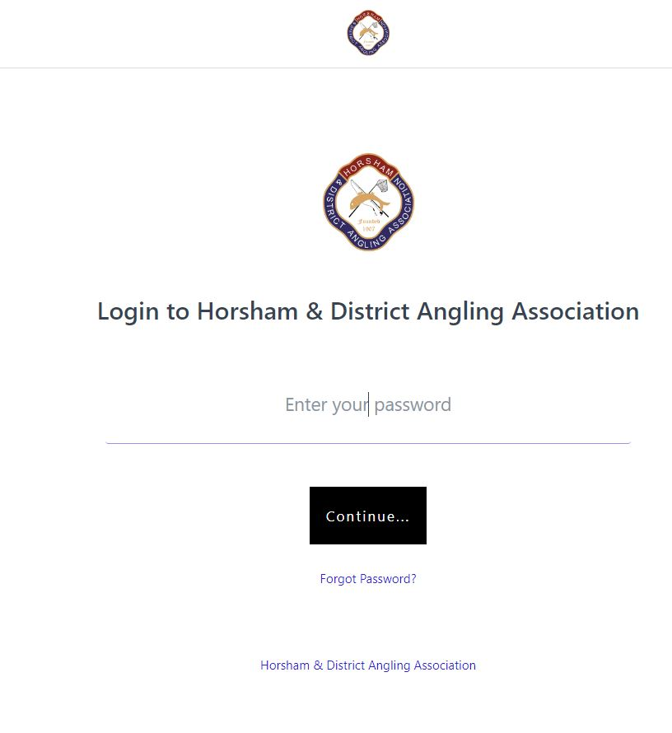

You will then be taken to your members page, that looks like this..

(Apologies that you must see my beautiful wife)

Choose the tile with the Yellow renew tab which shows your current membership.

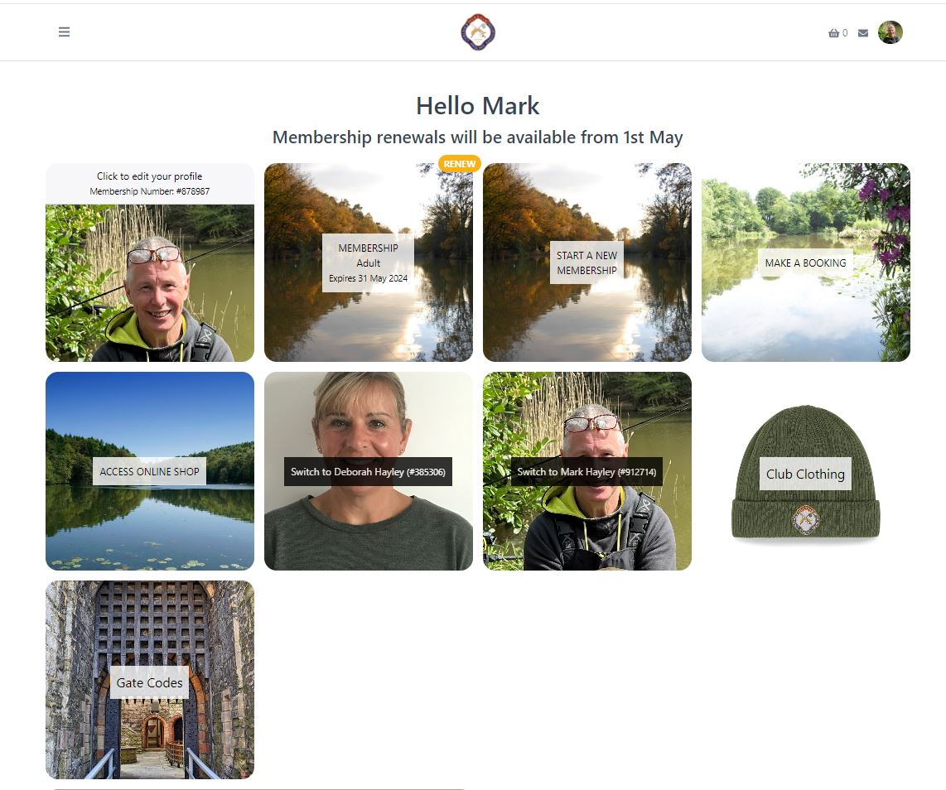

This opens a new window which shows your membership plan again with renew now.

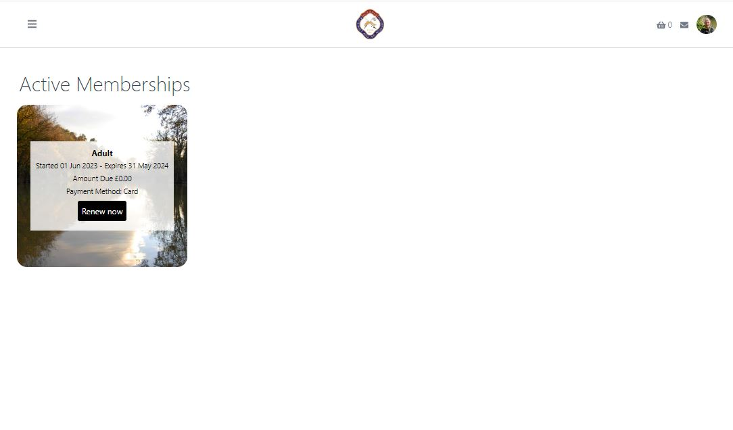

Click on that and the “renew your membership” page opens, this year if you are a renewing fishing member over 18 then you can choose from a plan with or without a night permit,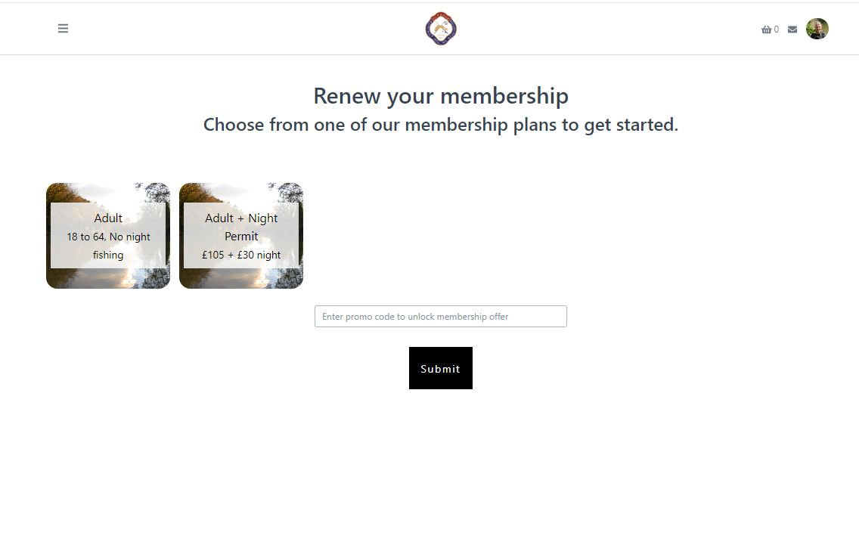

A new window will open showing the plan you have chosen, check its correct and then click on the black bar “select membership”

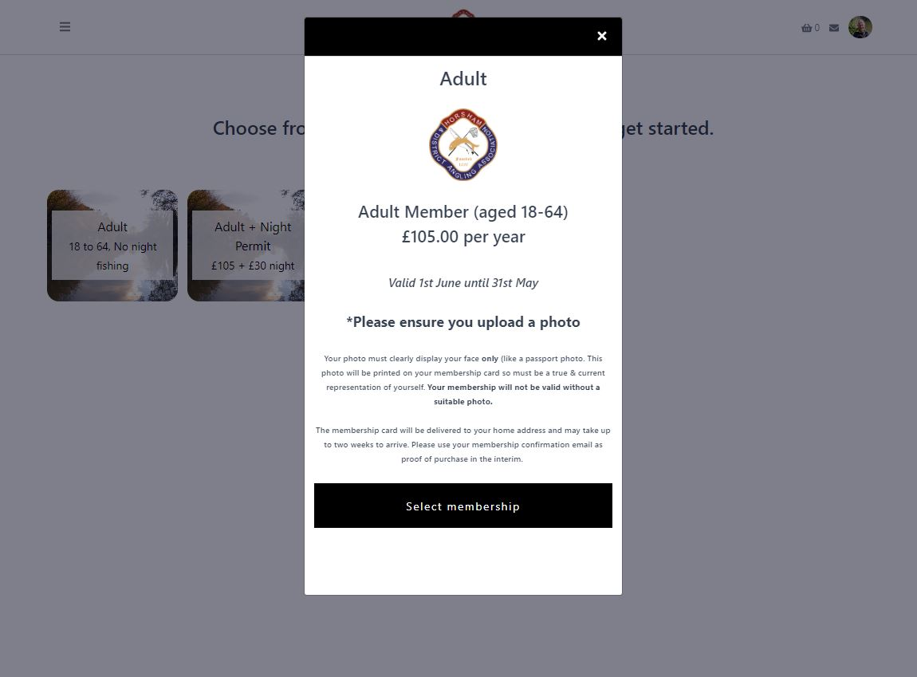

Another Page opens where you can check your details & amend if needed.

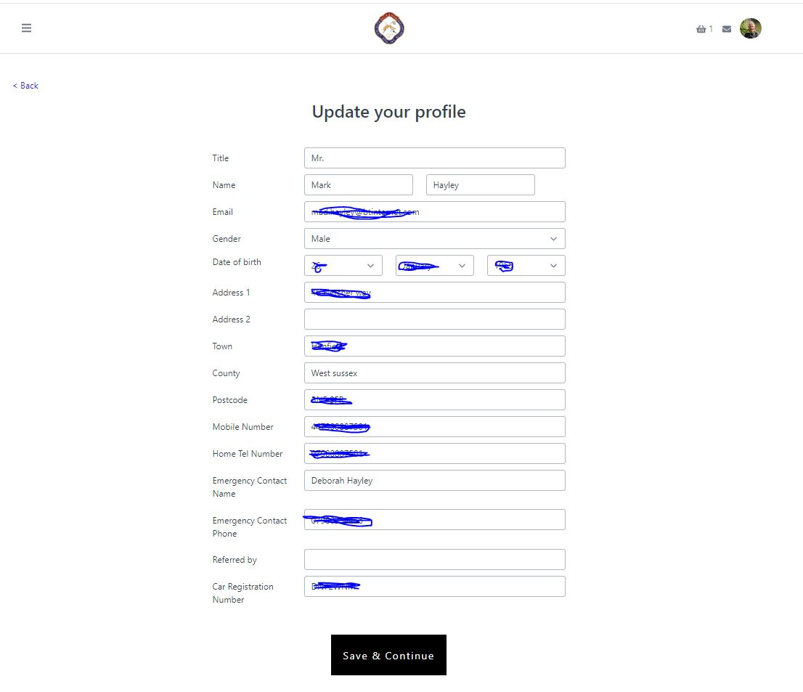

Once you're happy with them you can click “save & Continue” the fish fund donation appears, choose a value (only if you want too) and then continue again

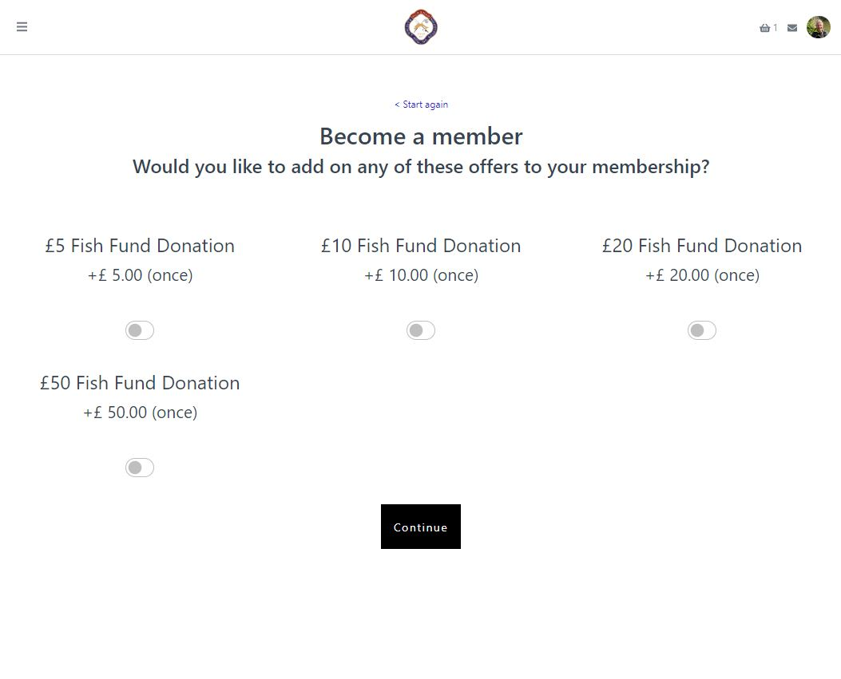

You then are on the payment page, check again that the membership plan & cost are as expected (remember the cost of the donation will be in this figure) and pay using your stored card or if its expired you can add a new one,

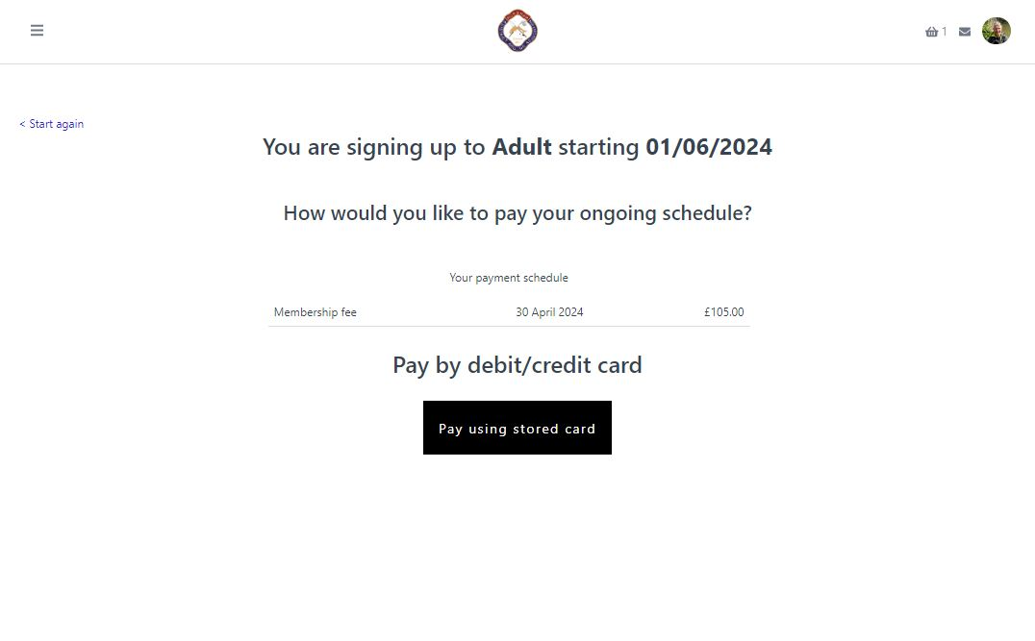I hope that has explained to process, it is very straightforward however should you run into any difficulties I will try and help, email me at the membership@hdaa.co.uk email address.

***Please renew your membership at your earliest convenance, we have over 120 people on the waiting list and it could be three or four years before you would get your place back should your membership lapse.***

Good luck, tight lines and have an amazing 2024/25 season.

Mark Hayley

H&DAA Membership secretary