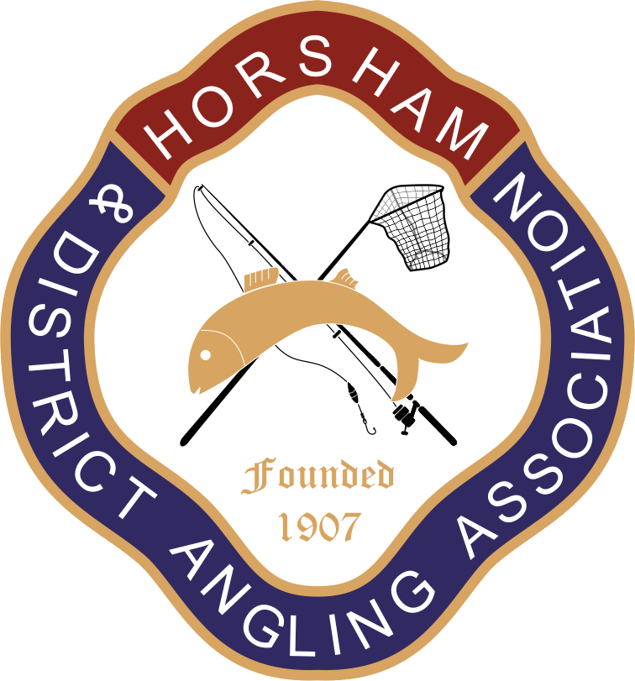

Horsham and District Angling Association (H&DAA) 2026 Newsletter
Dear Members,
Welcome to the 2026 edition of the club’s annual newsletter.
Please take the take the time to read through this newsletter. It contains information of all that has been happening at the club over the last year, as well as details of plans for the coming year
Contents
- Club chairman’s forward
- Club committee
- Annual general meeting
- Club waters
- Welfare officers update
- Membership and subscriptions
- Rule changes
- Pike teach-Ins
- Stocking
- Plans for 2026 – 2027
- Useful Links
6. Membership and Subscriptions
Subscription rates for the 2026 2027 season will be discussed at the AGM.
Renewals will be available from 1st May 2026. Existing members have until June 15th 2026 to renew, at which point we will offer any unsold memberships to those on the waiting list. Members who do not renew before this time and later wish to renew may have to join the waiting list, which is currently lengthy!
As always if you have issues renewing please contact the Membership Secretary: membership@hdaa.co.uk
Existing members should follow the same process to renew as last year by logging into your profile on Clubmate and follow the instructions to renew.
Ensure your details are all up to date, especially if you have moved and have changed address or e-mail. New memberships will be delivered to the address shown in your Clubmate profile.
Replacement cards due to wrong information are charged at £7.50.
Can the parents of Junior & Minor members please ensure their pictures are updated?
You cannot do this yourself but need to email a new picture to membership@hdaa.co.uk and we will change it for you.

Clubmate who issue our membership/ID cards have changed the format for the upcoming season as you can see below.
This just means all the details are on the front of the card along with a new QR code that will allow the club bailiffs to “check in” the member.

- Club Chairman’s forward
We have undertaken a lot of work this season which is covered later in the newsletter and at the end of this season and into the coming season will be continuing with both planned and unplanned.
Lee Waller, Fisheries Officer and Tom Sayer, who took over the role of deputy fishery officer when Tony Staples stood down have done a great job organising the work parties that have carried out the work. However, we still only have a small number of our members who help on a regular basis. The club need as many people as can spare some time to carry out maintenance tasks on our waters to ensure they are kept to the highest standards we can. Even if you can only join one work party a year, this makes a positive difference to the club. Please contact Lee if you can help.
Peter Collins and Colin Wadey have continued their amazing work around Island Pond and Foxhole keeping it all neat and tidy. I helped them remove a fallen tree at Island Pond earlier in the year and spent most of the time laughing at their banter with each other. Thank you guys!
Chris Jenkinson has now stepped down from his position as welfare officer, Sally Bicknell is now taking over as our new welfare officer which we are required to do to ensure the safety and wellbeing of members and he continues to keep abreast of requirements and diligently ensure we as a club are complying.
Kevin Rice, our Head Bailiff is our link between members and the team of bailiffs who ensure our waters are not poached and that members follow the club rules. Please show them the respect they all deserve they do a thankless job and do it well.
Ray Smallwood, our Treasurer who has been doing this job for ever it seems keeps all our financial records and manages to translate money speak into English at the committee meetings and AGM so we all know where we stand financially.
The committee members are a dedicated group who give up hours of their time to ensure you the members are represented and your fees are spent as best as possible to make sure you continue to enjoy your fishing. Maybe you do not always agree with things that are done but everything decided by the committee is done to benefit the club and its members.
FOXHOLE UPDATE from the Chairman
After moving 30 tonnes of clay, 12 tonnes of topsoil and 20 tonnes of crushed concrete the dam at Foxhole is mostly complete.
This could only be done after the 5 old swims were replaced using plastic piling, so they will never rot and hopefully never need replacing, unless one of the big trees decides to drop on them as almost happened on three occasions during the project. The latest being the big dead hollow tree that broke off and fell right across the new nicospan barrier; but, luckily for us it dropped exactly between two wooden stakes minimising the damage. You could not have placed it better with a crane!
The final work entails finishing off the swims with some more crushed concrete, topping off with woodchip and planting up the areas between the swims which have been fenced with some marginal plants, these we need to protect from the geese as everything we have planted so far has been eaten within hours of planting.
This has been a long hard project through the heat of summer with what I can only describe as bare minimal help from members when asked. We have a small core of dedicated people who turn out week after week to get things done, not only at Foxhole but at our other venues.
People I would like to mention are Richard Kirwan who manged to get us a digger for the weekend from his place of work, along with all the required clay and topsoil, delivered the digger and Jim Gravet (Jim Jim) who drove the digger so magnificently!
Shaun Fuller who drove down from Addlestone with his small digger and other equipment when we moved all the topsoil and removed a couple of stubborn tree stumps and rhododendrons.
The “Wednesday Warriors” Colin Wadey, Peter Collins, Dawn Clark, Barry Bicknell, myself and Rod Taylor who turn up nearly every Wednesday morning to chip away at the required work at Foxhole to improve the lake and get it ready to start fishing again.
We are waiting on the EA to help return the fish to Foxhole and will supplement the stock with a donation from another private lake.
We are also waiting on the tress above the dam being made safe by a tree surgeon who has inspected them and has recommended removing the dead wood and overhanging branches. We have forwarded his recommendations and estimate to the land owners who at the start of the project agreed to undertake all the tree work on and behind the dam.
We as a club rely on the membership to help, where possible, with work around the lakes mainly with small work like basic housekeeping and maintenance. If the current lack of support and volunteers continue we have to make stark decisions on reducing the amount of work that is carried out due to lack of labour, or bring in labour and pay for it. The latter could realistically result in membership fee increases over and above the normal token increases.
Someone said “what’s in it for me to do this work”. Apart from a well-kept, well maintained safe place to enjoy the sport/pastime we all enjoy and the chance to meet other members and give something back to the club, absolutely nothing.
Massive thanks also to Raymond Bulbeck for the work on the new overflow and also work at the other lakes in the past year.

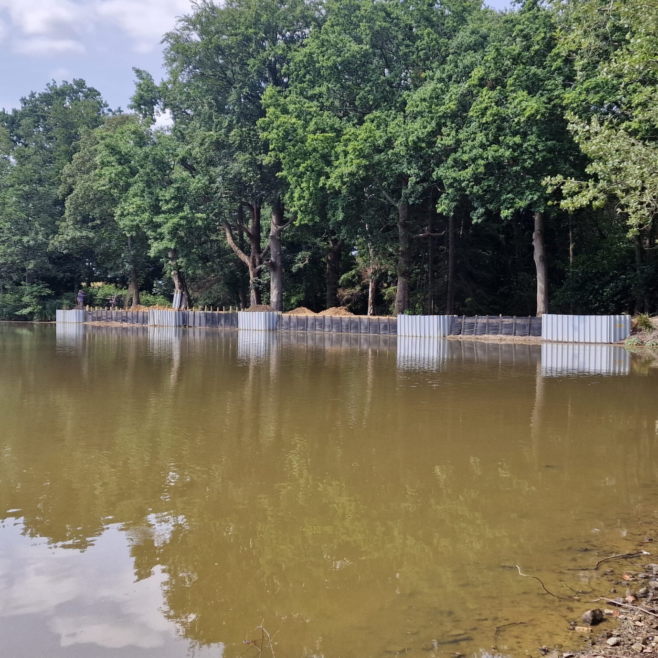

We plan to re-open Foxhole this year and will let all members know asap.
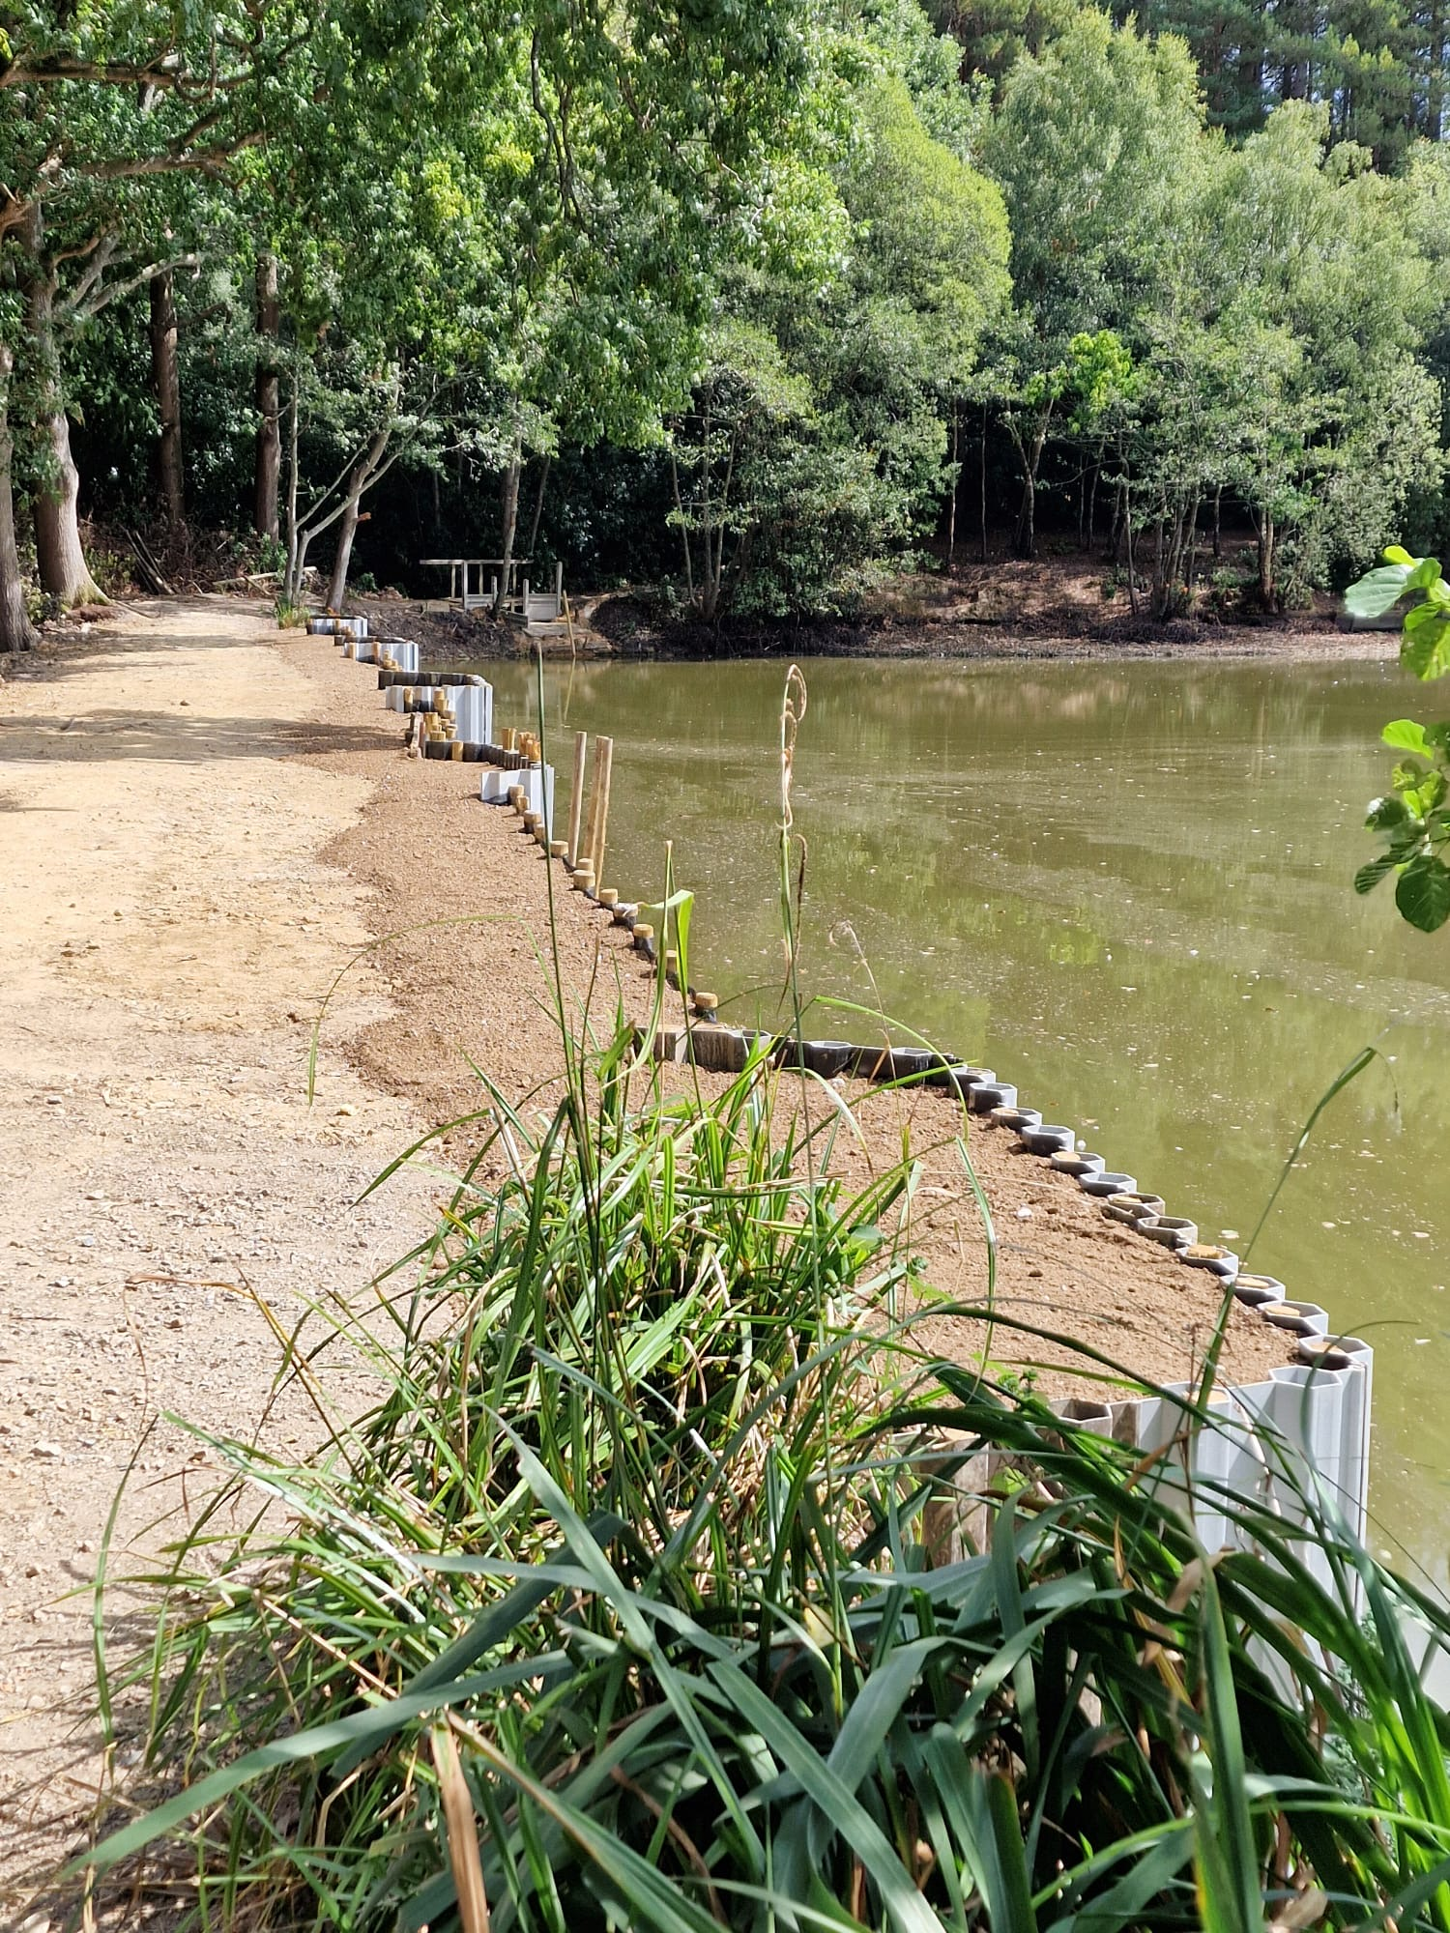
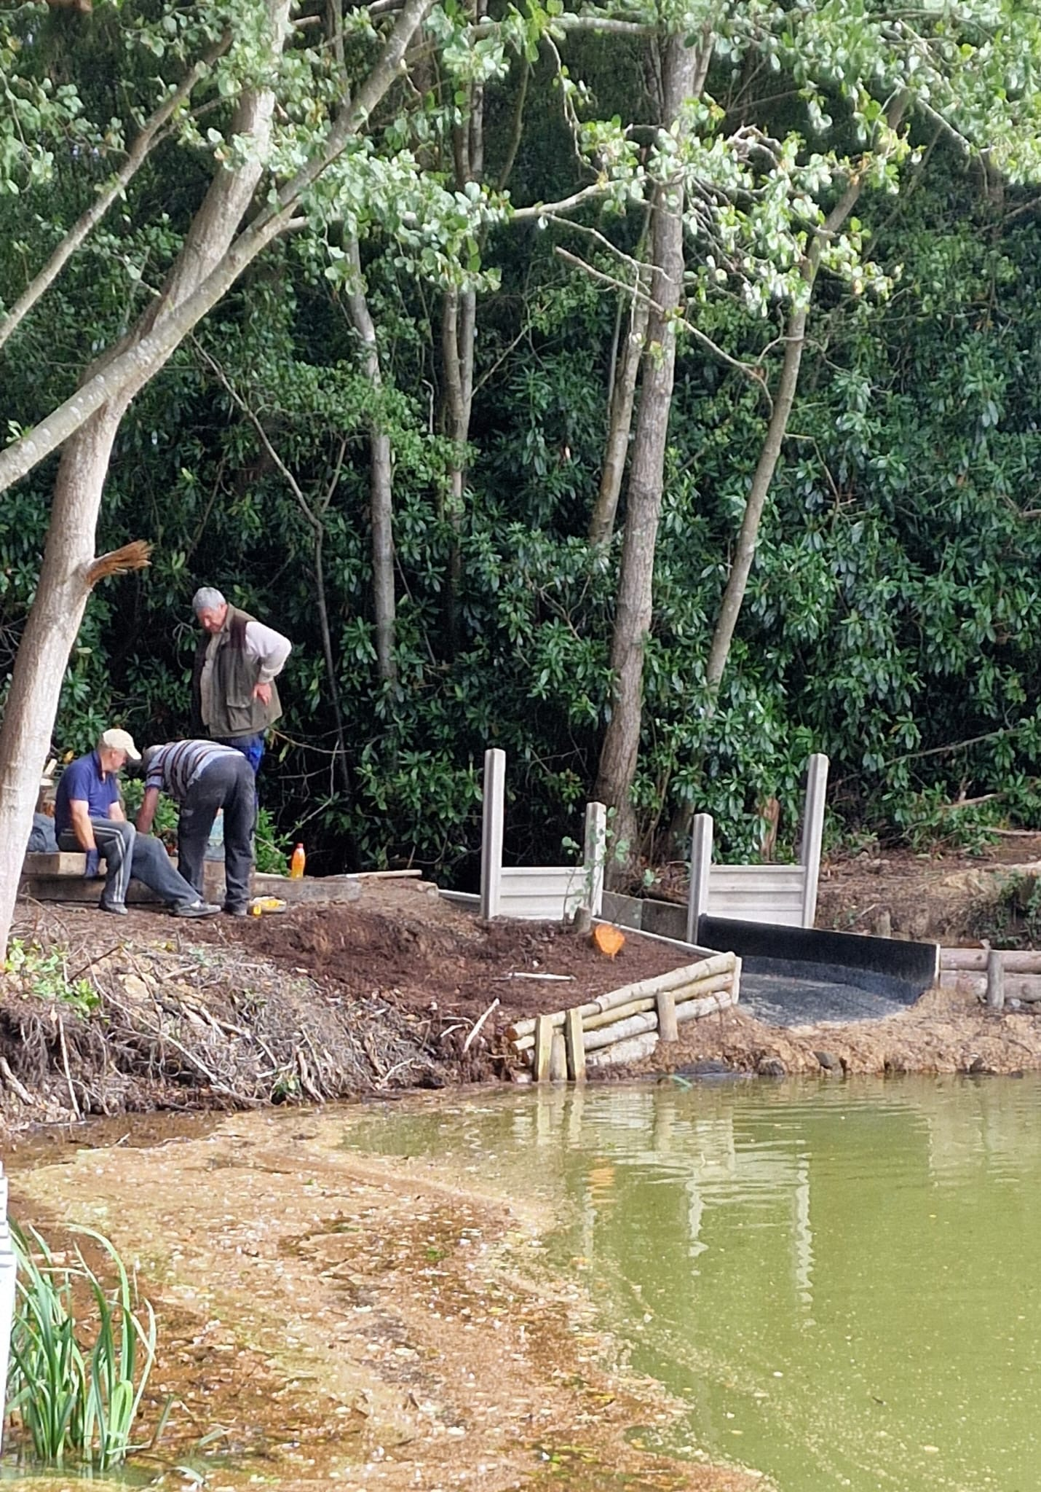
Great work on the overflow Raymond & Lee.
2. Club Committee
The club committee currently consists of Barry Clark (Chairman), Ray Smallwood (Treasurer), Lee Waller (Fishery officer), Matt Howlett (General secretary),), Kevin Rice (Head bailiff), Tom Sayers (Deputy fishery officer), Colin Wadey, Pete Collins and Graham Boylett, Sally Bicknell (Welfare Officer), Barry Bicknell.
During the year Chris Jenkinson has had to stand down as our Welfare Officer for personal reasons, and we would like to thank him for his time and efforts in setting up this vital role for our club.
Recently we were lucky to have Sally Bicknall join the committee as our new Welfare Officer, subject to ratification at the AGM, who brings a wealth of experience in this role.

Changes in the club committee over the last year are described in the previous section.
- Annual general meeting (AGM)
The club’s 2026 AGM will be held at the usual venue, The Roffey Social and Sports Club (Spooners Road, Roffey, RH12 4DY) on Wednesday 15th April. Please arrive at 7.30pm for an 8pm start. There is also a bar.
The club encourages all members who can make it to attend the AGM. The AGM gives all members the opportunity to have their say and influence how the club is run. It gives the committee an opportunity to get input and explain the work the club has done in the last year and plans for the future.
As usual, we will vote in the officers and committee during the AGM. Anyone who wishes to stand as a club officer, is encouraged to do so at the AGM.
We will also vote on proposed changes to the club rules. For further details, see the newsletter section “Rule Changes”.

- Club waters
A heartfelt thank you to all members who have contributed to maintaining and improving our waters this year! The club depends on volunteers for this work, which benefits all of us by saving the club thousands of pounds each year. This feeds through to the cost of membership.
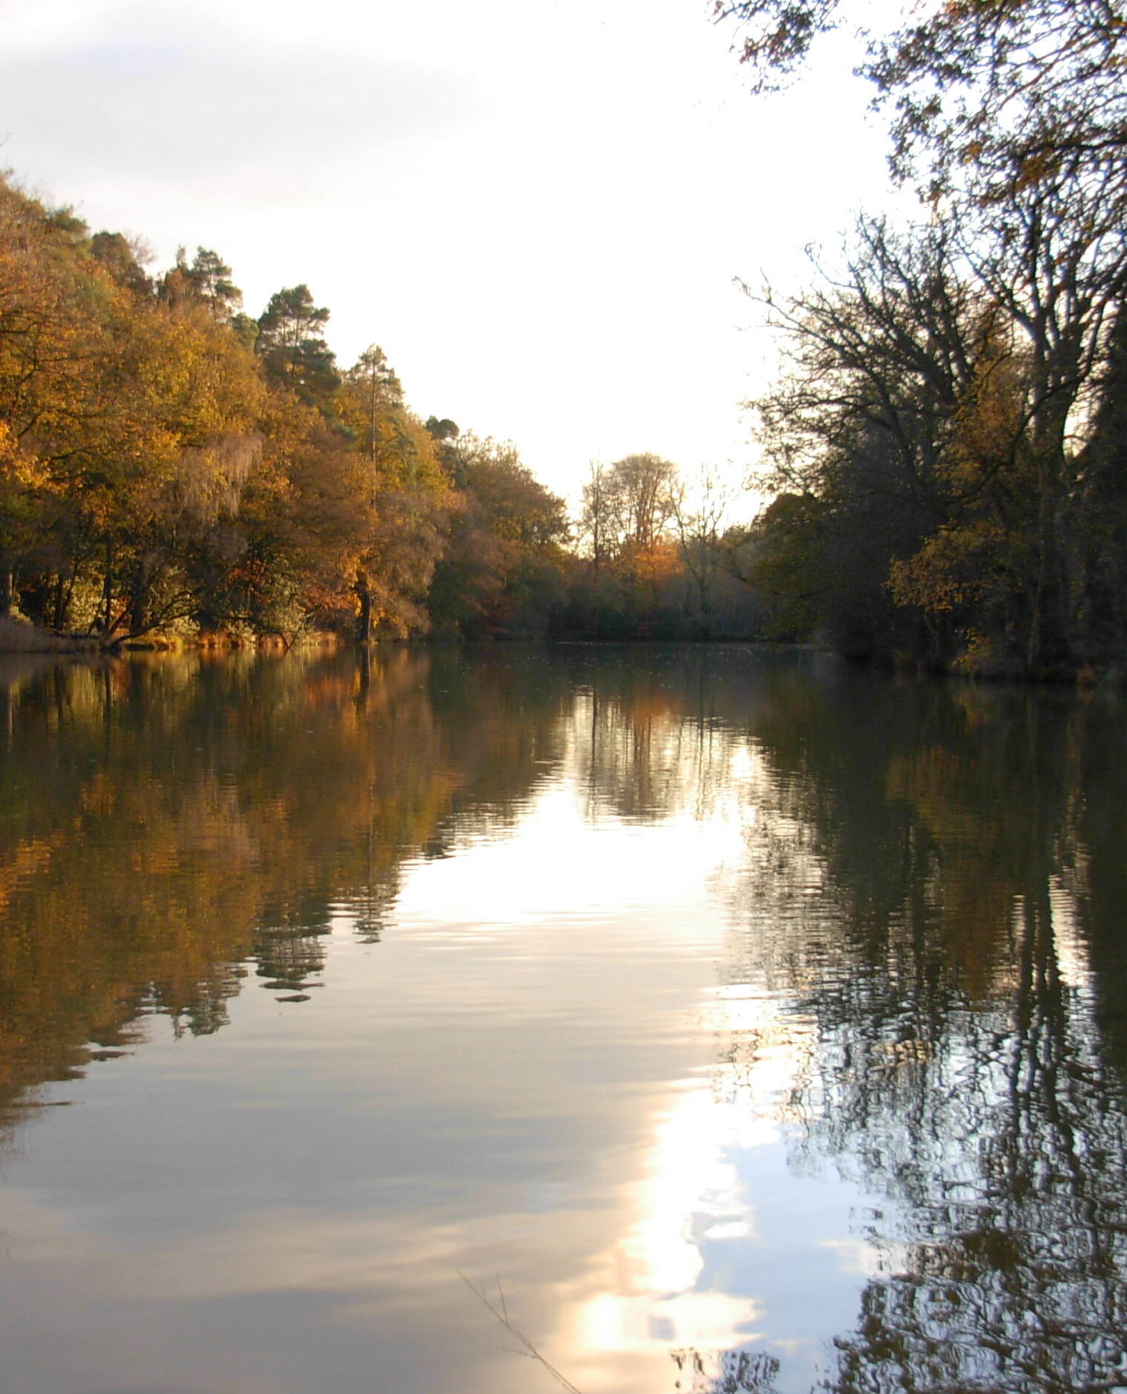
Our fishery officers (Lee Waller, Tom Sayers are both dedicated and hard-working but cannot do everything on their own and always welcome offers of extra help, particularly from anyone with specialist skills.
We publicise work parties on the club’s Facebook page. If you are able contribute, however large or small, it will make a difference. Lee can be reached on 07745 464315.
The club also depends on invaluable work carried out by Kevin Rice and his team of bailiffs who ensure that the club’s waters and assets remain safe. Please continue to treat them with the respect they deserve.
Below is summary of some of the work carried out at club waters over the past year. Further details can be found on the club’s website and Facebook pages.
Roosthole:
- Path around the fire pit area
- Swim 2 replaced with composite
- Wire mesh fence installed Horsham Bank
- Trench dug behind swim 24 to drain water off
- Fire Pit dug and rocks installed around it
- Seat made in Swim 11
- Lots of dead trees removed
- New Lilly's put in lake, along with bankside Iris Plants
- Wood Chip in most Horsham Bank Swims
- New Walkway/Bridge on woodside to give safe access to the far bank

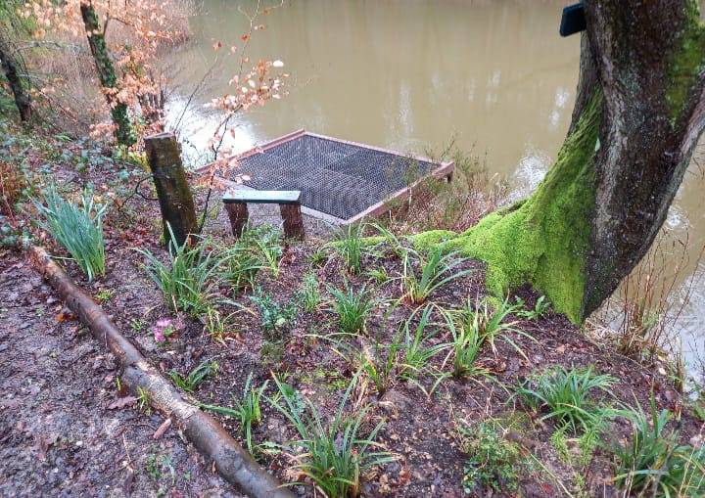
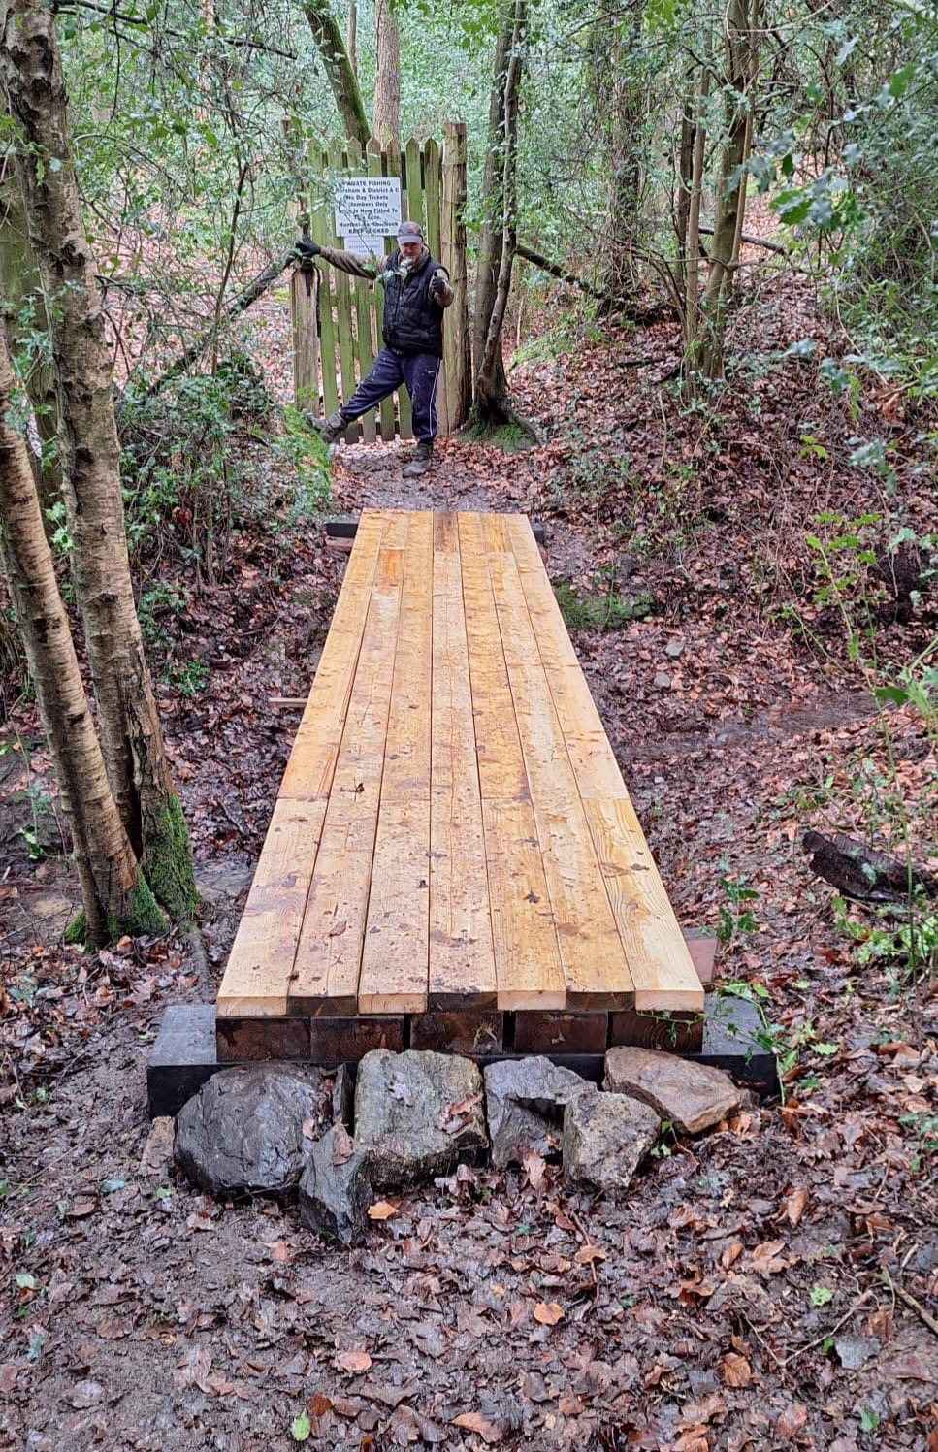
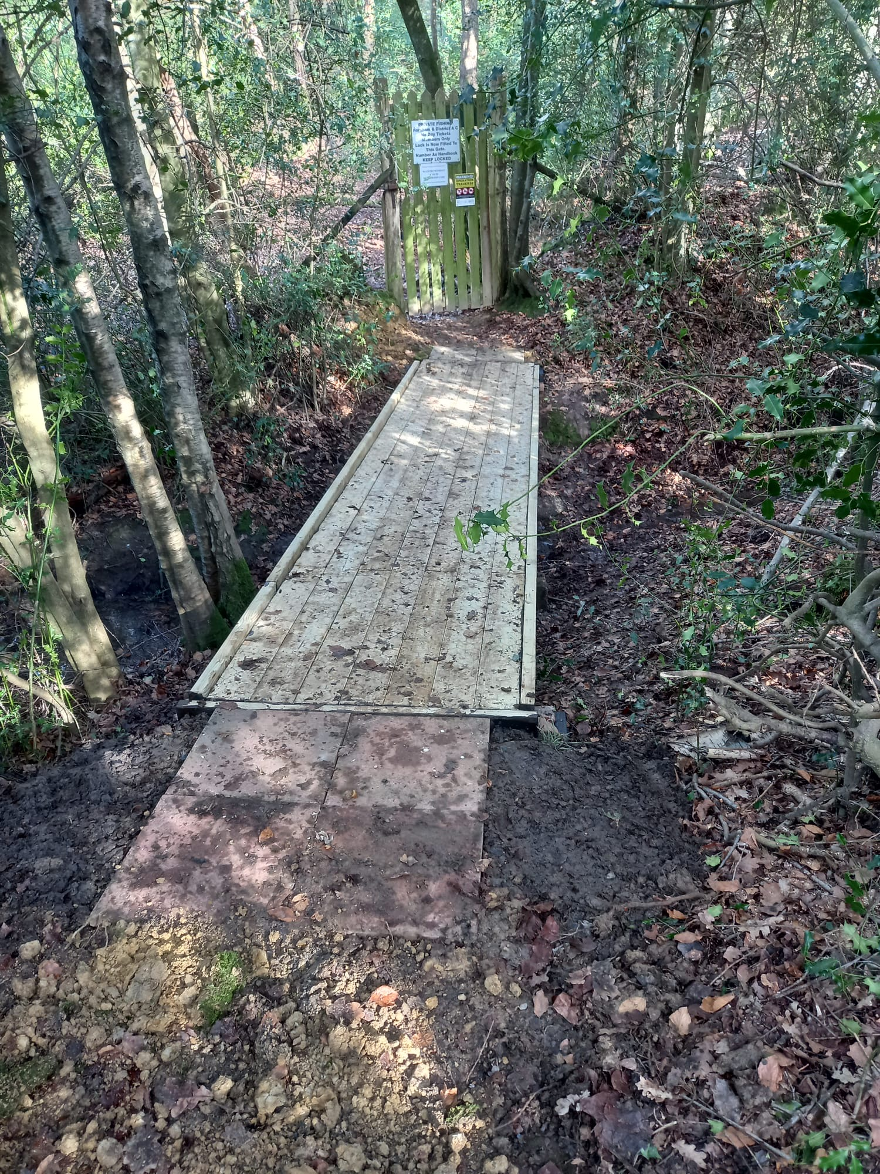
Following a successful trial last year, Roosthole will be closed during the period when the carp spawn. Members will be informed by e-mail and announcements on the club website and Facebook. Announcements will unavoidably be made at short notice, so please make sure to check before fishing Roosthole during the spring.

Birchenbridge:
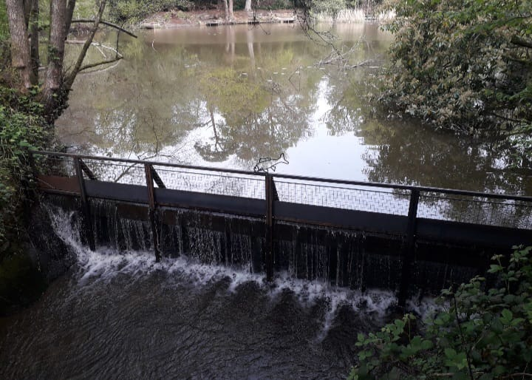
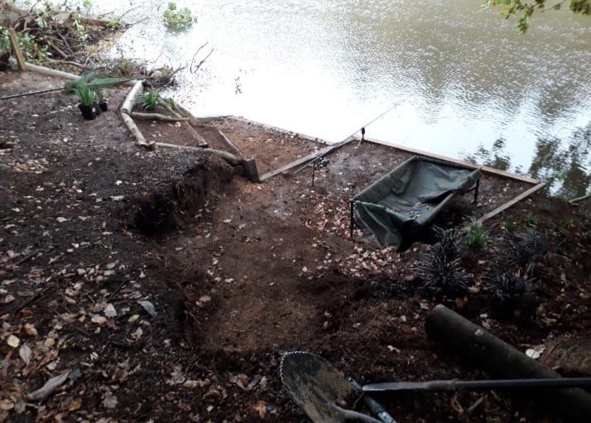

- New outlet frame kindly made my member Murry who spent a lot of time fabricating for us so thank you Murry for all your hard work.
- Lots of fallen and dead trees removed
- 6 new swims made along the Horsham Bank.
Big thanks to Kevin Shea, Lee Waller, Tom Sayers and the many others that helped on this project.

Foxhole: see above

Island Pond.
- New Gate and fence installed on dam woodside
- Swims repaired
- Track and car park improvements
- Channel dug for water run off
- Dangerous dead Trees cut down
Committee members Pete Collins and Colin Wadey have also carried out a tremendous amount of additional work at Island Pond (and Foxhole) keeping the venue in top condition.
Massive thanks to Raymond Bulbeck for his hard work on the overflow at FOXHOLE.
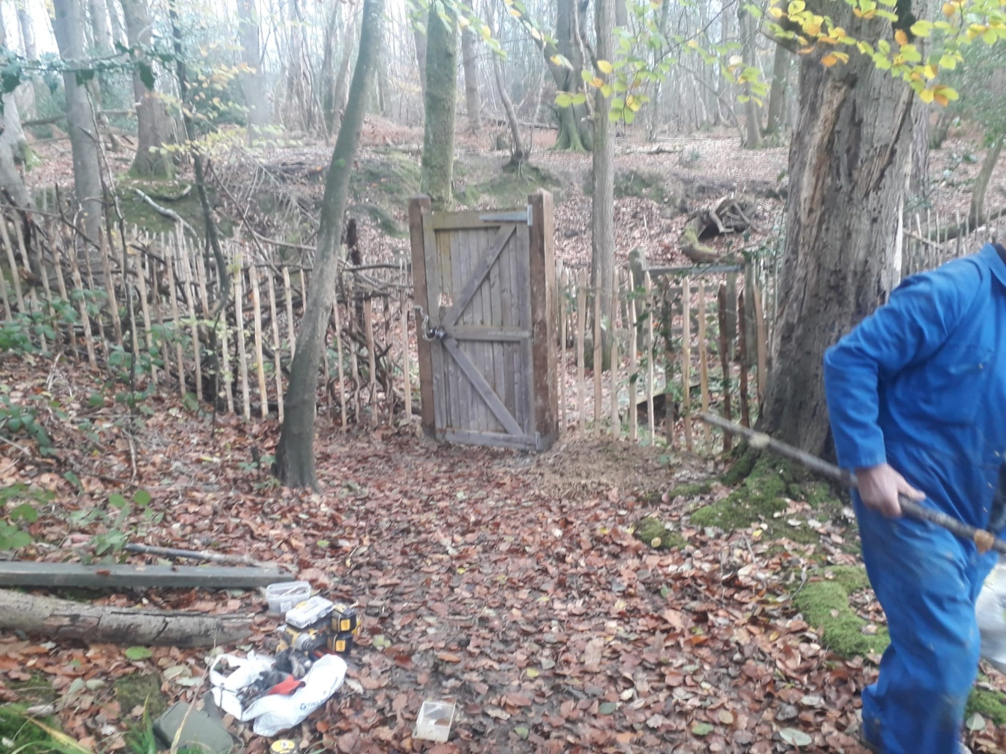
Sunoak Farm/Blackbottom ponds:
1. At Sunoak, a considerable amount of work cutting back rhododendron has been done, whilst information boards have been added at both venues to benefit members of the public. Fencing at both venues has also been improved, Outlet cleared several times.
BSA:
Members should be aware that the water at BSA lakes becomes very deep, very quickly. Some swims are also rather cramped and precarious, particularly on the lower lake. Please take special care when at the venue to ensure that you are fishing safely.

- A few swims made safer
- Paths trimmed and further work planned.

- Welfare officers update

In October last year we received an email from a member voicing their concerns regarding the welfare of junior, minor and vulnerable members.
We looked into these concerns and following advice from various professional bodies including the Angling Trust’s welfare officer, we convened an extraordinary committee meeting where we discussed the advice and agreed on a series of actions to alleviate the concerns raised and ensure the club complies with the latest welfare guidelines which include:
A parental consent form, available from our website, will have to be completed for any member under the age of 18 prior to any club activity. Failure to hand in the completed form before the start of an activity will result in the member being excluded.
Activities affected:
- Club match
- Club Teach-in/instruction event (Pike Teach In)
- Club work party
Link to safeguarding area of our website: Safeguarding - Horsham & District Angling Association
- Clubmate activity descriptions have been updated to include a detailed description and links to the Parental Consent Form and inform attendees that photographs may be taken to promote club activities.
- If the club appoint an official club photographer at an activity, we must ensure they are introduced at the beginning of the activity and they are clearly distinguishable. i.e. high vis vest marked “Photographer”
- The club must ensure we adhere to the “The Taking and Sharing photographs of Children Guidance”
- All bailiffs, committee members and club volunteers will need to complete a “Volunteer Self Declaration Form”
- The club should have a separate email address for the clubs Welfare Officer as any welfare issues should not be discussed on a personal email address.
- hdaawelfareofficer@gmail.com
- The club’s welfare officer will monitor the club’s social media to ensure the welfare of all members.

Safeguarding: The welfare of our members and their guests when fishing club waters is a priority. It is vital any concerns about the safety of junior or vulnerable adult members are reported to the club Welfare Officer so that the club can take steps to resolve them.
All club members must be aware that they have a responsibility to report anything that strikes them inappropriate in connection to the club.
Social Media: Please remember that our Facebook page is for sharing angling information. The club recommends that jokes are not put on our site as one person's idea of fun may not be another's. If you wish to comment on the running of the club please contact the committee directly rather than putting comments on Facebook.
- Membership and subscriptions
Subscription rates for the 2026 - 2027 will be TBC , as detailed on the club website
Renewals will be available from 1st May 2026. Existing members have until early June 2026 to renew, at which point we will offer any unsold memberships to those on the waiting list. Members who do not renew before this time and later wish to renew will have to join the waiting list, which is currently lengthy!
If you are an existing member, follow the same process to renew as last year by logging into your profile on the club website and following the instructions to renew. Ensure your details are all up to date, especially if you have moved and have changed address or e-mail. New memberships will be delivered to the address shown in your clubmate profile.
A guide to renewing membership is available for those unfamiliar with the process.
A variety of new bookable tickets were also introduced last year. Details can be found on the club website.
- Rule changes
Several changes and additions to club rules have been proposed this year by committee members. These are detailed in an annex at the end of the newsletter. Additional rules changes may also be proposed by members at the AGM (not included in the annex for obvious reasons). Please read these rule changes as they will be debated and voted on at the AGM. If you have strong feelings about any of them, or would like to propose any other rules, we look forwards to seeing you at the AGM.

8. Pike Teach-Ins
Members wishing to fish for pike on our waters are required to attend a pike teach-in. Members will be informed of the dates and invited to attend in the early Autumn. An attendance card is issued to those who come along, and bailiffs subsequently check anyone pike fishing on our waters to make sure that they have done so and are in possession of this card.
- Stocking
We are currently working on two projects for stocking, in 2025 we were offered fish from local ponds , Christ Hospital and a pond in Faygate, we have health checked the Faygate fish and in process of doing the same at Christ Hospital, there are various species including Tench, carp, Bream and silvers and we hope to be able to stock these fish into our lakes later this year, which lakes TBC.

- Plans for 2026/27

I
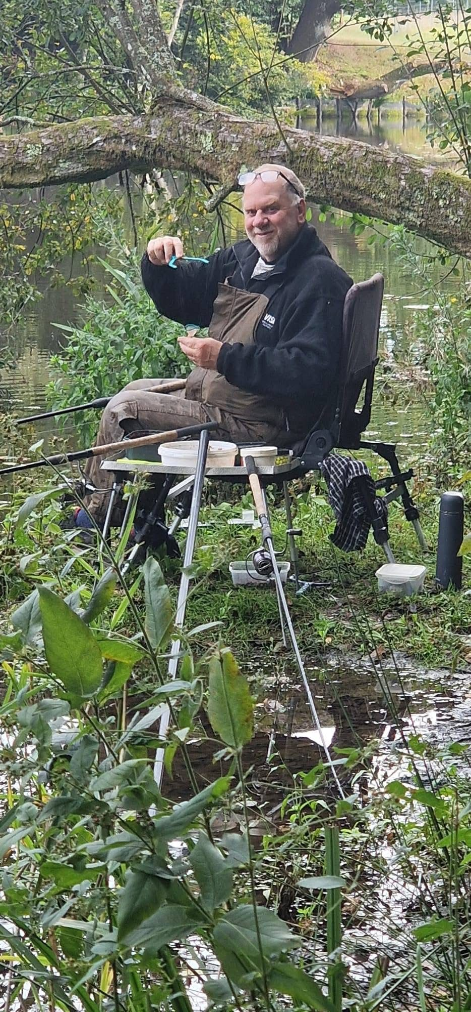

The club also plan to run League matches throughout the year (these will be organized by Lee Waller moving forwards).

After a match at Roosthole
Watch for announcements about all the matches the club will hold in the coming season on the club website and on Facebook. We encourage all our members to take part, especially those who have never fished a match before and would like to give it a try in a friendly and supportive atmosphere.
Details of match dates where they have already been pencilled in can be found on the match fixtures page of the club website.

We also plan continued lake maintenance, and any help would be gratefully received as there is always lots to do. We will advertise when we are completing work so please if any members can help just turn up even if it's just for a short while.
Big thanks to everyone that has helped the club in one way or another this past year, it is massively appreciated by the committee, and we could not do it without you, special thanks also to Kev Shea for the endless trips delivering stuff for the lakes and helping on many of the maintenance projects.
***
This concludes the annual newsletter. We hope very much to see you at the upcoming AGM.
Tight Lines
H&DAA

Annex Propsed (Rule changes)
19) A night fishing permit is available to all categories of fishing member over 18 years of age who have been Association Members for one full season, subject to an additional fee.
Members need to select the correct membership category, Adult + Night Permit, Disabled + Night Permit or Over 65 + Night Permit.
New Members who wish to night fish see rule 28 – Single Night Tickets.
Night permits are not available as a separate product.

Current Rule

SINGLE-NIGHT TICKETS
28) All categories of fishing member over 18 years of age who have been Association Members for at least one full season not in possession of a full night permit may purchase a Single-night ticket on their Clubmate app for an additional fee. Single night tickets must be paid for in advance, see club rules for further details.
Suggested Rule change:
SINGLE-NIGHT TICKETS
28) All categories of fishing member over 18 years of age who are not in possession of a full night permit may purchase a Single-Night Ticket on their Clubmate app for an additional fee. Single night tickets must be paid for in advance, see club rules for further details.
New members must inform the head bailiff where they are using the ticket.
This will allow new adult members to purchase single night tickets. When they purchase this product they will be asked to inform the head bailiff where they will be using the ticket so the bailiffs can check. Kevin will also receive an email when a new member purchases one.

Rules 19, 21, 30 and 31 (as currently published)

Proposed amendments
19) A night fishing permit is available to all categories of fishing members over 18 years of age who have been Association Members for one full season, subject to an additional fee.
Members need to select the correct membership category, Adult + Night Permit, Disabled + Night Permit or Over 65 + Night Permit.
Night permits are not available as a separate product.

Night permits will allow fishing with up to 3-rods at night provided the member has a corresponding EA rod license.

21) Members with night permits may use 3 rods at night from 11pm to 6am only. (Remember an EA 3 rod license will be required.)

- Two rods, two lines, (one hook each) shall be allowed at the same time by each individual, with the exception of Minors and those accompanying Minors, when only one rod per individual may be used. All members must adhere to Rules 59 and 60 when placing rods regardless of the number of rods being used. Members with a 3-rod EA license may fish with 3 rods at the times specified under the night fishing rules.

- 3-rods may be used at Birchenbridge during the day by members holding a night permit and corresponding EA licence. Any rods that infringe on another angler’s swim, even if they arrive later, must be reeled in and relocated. Members holding both a night fishing permit and the appropriate EA rod licence(s) may use three rods at the following venues and times only, provided they are not fishing for pike:

  - Birchenbridge – at any time

Roosthole, Island Pond and Foxhole:
    - From 1 March to 31 October: three rods permitted between

7pm and 7am
    - From 1 November to the end of February: three rods permitted at any time

